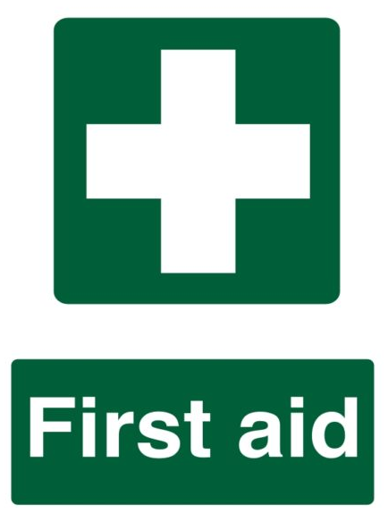

First Aider List, December 2023

First Aider | E-mail | Room
Howard Chan | howard.chan@glasgow.ac.uk | ****
Connor Fleming | connor.fleming@glasgow.ac.uk | A3-07
Zoe Michel | zoe.michel@glasgow.ac.uk | A3-25
Euan Stobbs | euan.stobbs@glasgow.ac.uk | A3-25
Marcox Pun | marcox.pun@glasgow.ac.uk | A4-32c
Haralampos Moiras | charalampos.moiras@glasgow.ac.uk | A4-42
Jessica Walker | jessica.walker@glasgow.ac.uk | A5-27
Andrew Monaghan | andrew.monaghan@glasgow.ac.uk | B2-27
Alec Mungall | alexander.mungall@glasgow.ac.uk | C3-03b
Alex Loch | alex.loch@glasgow.ac.uk | C3-08
Gillian Laidlaw | gillian.laidlaw@glasgow.ac.uk | C4.03a

Mental Health First Aider | E-mail | Room
Howard Chan | howard.chan@glasgow.ac.uk | ****
Angela Woolton | angela.woolton@glasgow.ac.uk | ****
Euan Stobbs | euan.stobbs@glasgow.ac.uk | A3-25
Frances Docherty | frances.docherty@glasgow.ac.uk | A4-15
Emily Draper | emily.draper@glasgow.ac.uk | A5-13
Jessica Walker | jessica.walker@glasgow.ac.uk | A5-27
Mario Gonzalez Jimenez | mario.gonzalezjimenez@glasgow.ac.uk | B3-21

Oxygen Therapy First Aider | E-mail | Room
Howard Chan | howard.chan@glasgow.ac.uk | ****
Connor Fleming | connor.fleming@glasgow.ac.uk | A3-07
Zoe Michel | zoe.michel@glasgow.ac.uk | A3-25
Euan Stobbs | euan.stobbs@glasgow.ac.uk | A3-25
Alec Mungall | alexander.mungall@glasgow.ac.uk | C3-03b

Call 0141 330 4444 (or 4444 on internal landline phones) for Emergency Services.

First Aid assistance can also be accessed (including out of hours) by calling Security on 0141 330 4444 or via the SafeZone app.

The nearest AED (defibrillator) is located in the entrance foyer of the Wolfson Medical building or the workmen’s courtyard of the Isabella Elder building.

