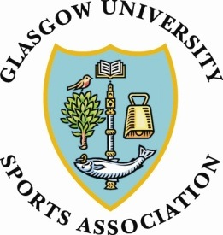

Glasgow University Sports Association
AGM- 20st March 2018, 6pm
Minutes
- Present
Student GUSA Council members (elect), GUSA Council representatives, club representatives, University Sport members, Senior GUSA Council members
Apologies:
Gemma Adair
Absent: 4 clubs

- Ratification of last minutes
The minutes from 18th April 2016 were approved and no amendments were required.
Proposed: Shereif Kholeif
Seconder: Patrick Everingham
Vote taken- 88

- Presidents Report
Cry :’(

- Honorary Treasurer’s Report

Proposer: Andrew Gillespie
Seconder: Christina

- Ratification of Election Results

Senior Council:
These members are there for the support and advice, not eligible to vote but are strong allies to the association. First is the ratification of the senior council members, to re-elect current members:

Frank Coton: Honorary President
Phillip Morrice: Honorary Treasurer
Desmond Gilmore: Court Representative
David Denton: Honorary Vice President
Derek Casey: Honorary Vice President

Proposer: Nelli Vanninen
Seconder: Olivia Robertson

Student Council
President – Paddy Everingham (unopposed)
Vice President – Shereif Kholeif (opposed)
Honorary Secretary – Louise O’Neill (unopposed)
Alumni Convenor- Eve Cobbett (unopposed)
Club Sport Convenor – Nelli Vanninen (unopposed)
Events Convenor- James Topping (unopposed)
Finance Convenor – Olivia Turner (opposed)
Fundraising & Outreach Convenor- Jason McBurnie (unopposed)
Health and Fitness Convenor – Kieran Dowling (unopposed)
Publicity Convenor – Sami Mustapha (opposed)
Travel Convenor – Jenny McGregor (unopposed)
Welfare Convenor – Christina Thompson (unopposed)
Proposed: Lucy White
Seconded: Leon Hay
- AOCB
The new constitution was passed
Proposer: Patrick Everingham
Seconder: Sami Mustapha
IH closed the meeting.

