toilet-sign[1]toilet-sign[1]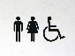toilet-sign[1]toilet-sign[1]toilet-sign[1]toilet-sign[1]toilet-sign[1]toilet-sign[1]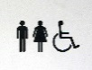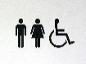toilet-sign[1]toilet-sign[1]toilet-sign[1]toilet-sign[1]toilet-sign[1]toilet-sign[1]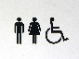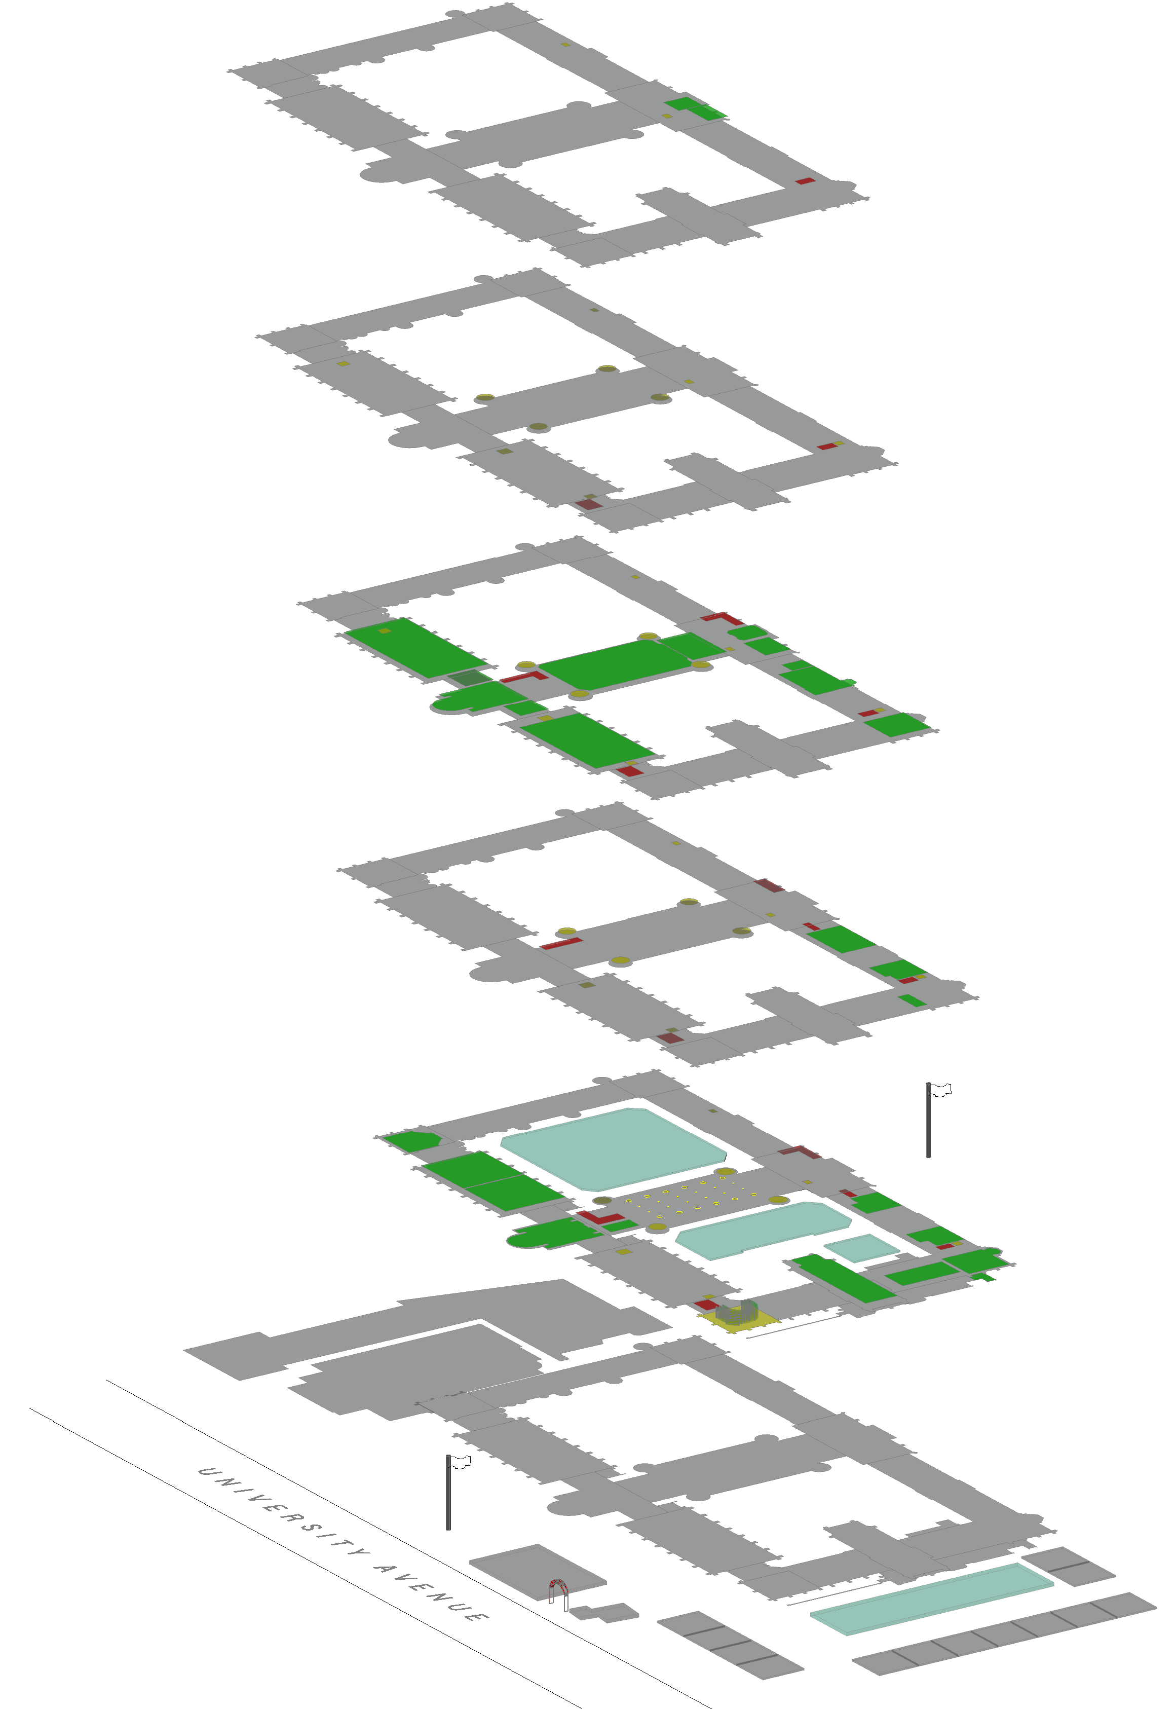

Gilchrist ‘Wee G’ Seminar 114

Gilchrist PG Club

**Room 134**

**Room 132**

**Room 137**

**Room 145** (accessible from Thomson Building)

145

137

Entrance to 132,134 & 137

**Platform Lift**

413

**ASBS**

**ASBS**

Lion & Unicorn Staircase

**Life Sciences Anatomy**

**ASBS**

**ASBS**

**ASBS**

**ASBS**

**ASBS**

**ASBS**

**ASBS**

**ASBS**

**ASBS**

**ASBS**

**ASBS**

**ASBS**

**ASBS**

**ASBS**

**ASBS**

**ASBS**

**ASBS**

**ASBS**

**ASBS**

**GES**

**GES**

Robing Room 219

Accessible Toilets

Toilets

Adam Smith Business School

Geographical & Earth Sciences

ASBS -

GES -

Accessible Entrance

Entrance to Quad

**GES**

Entrance to Quad

**GES**

**GES**

**GES**

**GES**

**GES**

**Turret D**

**Turret H**

Stairs to Levels 6 & 7

Museum Lift

**1A The Square** - Café & Brasserie

Fore Hall 256

Stairs to Rm 355

Room 253

Room 250

Humanity Lecture Theatre 255

Stairs & Lift to Room 356 & 358

Room 355

Stairs to Room 355

Room 358 overlooking Fore Hall

Lift & Stairs to Level 3

Museum Stairs

Lift to Museum

Stairs to Bute Hall

Lift to Bute Hall

Lift & Stairs to Level 4

Lift & Stairs to Level 5

Tower

Lift to Level 6

Lift to IT Services

**Turret G**

**Turret C**

Security Office

**McIntyre Bldg**

Gift Shop

**Anatomy** **Lecture Theatre 236**

**Anatomy Museum**

Thomson Building

Entrance to Thomson Building

Lift & Stairs

``

Inter-Faith Prayer Room

Business School Lecture Theatre 206

East Quad Lecture Theatre 226

Hunter Halls

Concert Hall

*Find the Accessibility Map at: www.glasgow.ac.uk/about/accessibility*

Kelvin Gallery Lift & Stairs to Level 4

*Updated Jan 2019*

“Stair Building” (School of Law)

**Museum Lift**

Euing Room

Lift Inside Museum

Museum Stairs

Lift & Stairs

to Level 5



Turnbull Room

Senate Room

**Turret A**

**Turret E**

Lift to Museum

Carnegie Room

Quad Stairs

Chapel

134

132

226

GILBERT SCOTT BUILDING (from University Avenue)

Hunter Room

Level 2

Level 3

South Front Flag Pole

466

356

355

**James Watt North**

`

Museum Stairs

Ferguson Room

Kelvin Gallery 413

413

256

255

253

250

**Main Gate**

Room 656A

Level 6

Melville Room

Bute Hall

Lecture Theatre 466

Room 356

Lift

North Front Flag Pole

**Turret F**

**Turret B**

**Quad Stairs**

**11**

**6**

**7**

**3**

Level 1

Stairs to Bute Hall

West 220

**East Quad**

**Cloisters**

Randolph Hall

Hunterian Museum

Main Hall

Bute Hall Stairs

Lift to Level 4

Level 4

Lift to Bute Hall

East 293

**9**

**10**

**12**

**West Quad**

Lift

Lift

Lift & Stairs

Museum Lift to Level 5

Lift

Lift to Level 5

Kelvin Gallery Lift & Stairs

**James Watt South**

**2**

**1**

**4**

**13**

**5**

**8**

Level 5

**The Square**

5