

Staff Equality Monitoring Report 2019-20

# Executive Summary

This is the ninth annual staff equality monitoring report produced by the Equality and Diversity Unit and follows largely the same format as the previous reports to allow comparison between years. This report supports the University’s obligations to publish annual staff equality monitoring data as part of the Public Sector Equality Duty (PSED) under the Equality Act 2010.

The publishing cycle reflects the previous academic cycle (August 2019 –July 2020).

The report shows the following important points and changes:

* The percentage of Females at Grade 10 has increased by 2.2% from 2018-19, to 33%, and means the University has achieved its Key Performance Indicator[1].
* The percentage of Females in the Senior Management Group (SMG) has increased to 57.1%; an increase of 21.4% from 2017-18.
* A significant percentage of staff returned from maternity leave in 2019-20 – about 80%.
* 8.6% of our staff are Black Asian and Minority Ethnic (BAME) background; a 0.1% drop from 2018-19. The highest percentages are in College of Science and Engineering, the Research and Teaching job family, employed at Grade 7 and on an Open-ended with funding end date contract.
* 4.4% of our staff have a declared disability - this is static from 2019-20. The highest percentages are in University Services, in the MPA job family, employed at Grade 4 and the largest impairment type is a ‘Long-standing Health Condition’.
* There has been a steep rise in the percentage of staff who are single when compared to those who are married/civil partner/co-habiting; this is the first time where single people is the biggest cohort at almost 45%.
* The report includes data on gender reassignment, BSL users and a Case Management section for the first time.

The data highlights a number of challenges; these include:

* An increasing percentage of staff have not informed us of their diversity details – particularly for ethnicity and disability, an increase of 4.1% and 3.5% respectively from 2018-19. This is a significant challenge when trying to understand the staffing cohort and requires urgent attention.
* The University continues to have a low percentage of UK nationality BAME staff (4.1%) when compared to our local community.
* The Operational job family has an older profile. This should be noted when considering succession planning. However, improvements have been made from 2018-19.
* Success rates for BAME job applicants continue to show large variabilities, with significant disparities in the Research and Teaching job family.

# Introduction

The Staff Equality Monitoring Report allows the University to have a standard base for all staff equality information across the organisation. This report meets one of the University’s obligations under the Public Sector Equality Duty (PSED).

The aim of this report is to provide transparent data for all functions in the institution to use when equality information is required, such as when conducting Equality Impact Assessments (EIA).

# Structure

This report has been structured to provide a ‘Whole University’ overview by all the main protected characteristics plus full/part time working, and maternity leave followed by specific sections on age, disability, ethnicity, sex and sexual orientation with a breakdown of data by the following:

* College
* Grade 10 staff
* Job Family Profiles
* Grade
* Full/Part Time
* Contract Type
* Nationality
* Recruitment – by all applicants and successful applicants

We have not provided a further breakdown beyond ‘Whole University’ on data for religion and belief as the proportion of staff answering these questions is too small to give meaningful information.

Further information has then been provided, by sex, on:

* Academic Promotions
* Regrading for Professional & Support Staff
* Equal Pay – Gender Pay Gap
* Case management

Information on Sickness Absences has been provided, by age, disability, ethnicity, sex, and sexual orientation.

# Notes and definitions

This report is based on a census date of **10 August 2020**, unless otherwise stated. Percentages have been used, as there are some instances where numbers are very small and using actual numbers carries a risk of identifying individual staff. Overall proportions for each of the sections have been provided in Tables 1-6 below.

Whole University - Total head count is **8691** (up 493 on last year). This is the head count for all staff in the University; with those on multiple contracts only counted once. The three previous year’s total headcount figures were 7528 (2016-17), 7655 (2017-18) and 8198 (2018-19).

College/University Services Split

When using the term ‘By College’ this includes University Services as a College.

|  |  |  |  |
| --- | --- | --- | --- |
| Table 1 - College | %2017-18 | %2018-19 | %2019-20 |
| Arts | 8% | 8% | **8.3%** |
| MVLS | 30% | 28.5% | **30.2%** |
| Science and Engineering | 20% | 20% | **19.7%** |
| Social Sciences | 12% | 14.5% | **14.8%** |
| University Services | 30% | 29% | **27.0%** |

Job Family Profile

Some members of the Senior Management Group (SMG) are classed as ‘Research & Teaching’ or ‘Clinical’ under the Job Family profile. For reporting purposes these have been moved into SMG, and the original Job Family figures have been amended accordingly.

|  |  |  |  |
| --- | --- | --- | --- |
| Table 2 - Job Family | %2017-18 | %2018-19 | %2019-20 |
| Clinical | 3.6% | 3.3% | **3.4%** |
| Management, Professional and Administrative (MPA) | 34.7% | 32.6% | **28.2%** |
| Operational | 11.1% | 10.1% | **9.9%** |
| Research & Teaching | 42.2% | 45.4% | **48.5%** |
| SMG | 0.2% | 0.2% | **0.2%** |
| Technical & Related | 8.2% | 8.4% | **9.8%** |

By Full/Part Time

All staff who work less than one FTE are considered Part Time.

|  |  |  |  |
| --- | --- | --- | --- |
| Table 3 - Full Time / Part Time | %2017-18 | %2018-19 | %2019-20 |
| Full Time = FTE 1.0 | 66.0% | 64.5% | **63.6%** |
| Part Time = FTE - 0 + anything < 1.0 | 34.0% | 35.5% | **36.4%** |

By Contract Type

The contract types are as follows;

**F** = Fixed term as per FT & OE Contract policy

**O** = Open ended with funding end date

**P** = Open ended + Permanent in Temporary Fixed Term Appointment

**S** = Fixed term - SOSR e.g. Maternity leave cover

|  |  |  |  |
| --- | --- | --- | --- |
| Table 4 - Contract Type | %2017-18 | %2018-19 | %2019-20 |
| F = (F) Fixed term | 16.5% | 20.2% | **22.8%** |
| O = (O) Open ended with funding end date | 19.0% | 18.0% | **17.4%** |
| P = (P) Open ended + (C) Permanent in Temporary Fixed Term Appointment (Head of College/Principal/Vice Principal roles etc.) | 62.9% | 60.4% | **58.7%** |
| S = (S) Fixed term - SOSR e.g. Maternity leave cover | 1.6% | 1.3% | **1.2%** |

Grade Grouping

|  |  |  |  |
| --- | --- | --- | --- |
| Table 5 - Grade Grouping | % 2017-18 | % 2018-19 | % 2019-20 |
| Grade 1 | 4.8% | 4.4% | **4.1%** |
| Grade 2 | 4.5% | 4.0% | **3.9%** |
| Grade 3 | 4.0% | 4.0% | **4.7%** |
| Grade 4 | 6.2% | 5.8% | **4.9%** |
| Grade 5 | 13.8% | 13.9% | **14.8%** |
| Grade 6 | 16.6% | 18.5% | **18.4%** |
| Grade 7 | 18.4% | 17.8% | **17.1%** |
| Grade 8 | 12.1% | 12.9% | **12.8%** |
| Grade 9 | 8.3% | 7.9% | **8.1%** |
| Grade 10 (see Table 6 for definition) | 7.1% | 7.0% | **7.4%** |
| Clinical | 3.6% | 3.3% | **3.5%** |
| Other[2] | 0.6% | 0.5% | **0.4%** |

|  |  |  |  |
| --- | --- | --- | --- |
| Table 6 – Grade 10 staff  (based on Actual Grade Description) | % 2017-18 | % 2018-19 | % 2019-20 |
| Professor | 88.3% | 88.0% | **88.5%** |
| Senior Administrative Group | 9.2% | 9.4% | **9.3%** |
| Senior Management Group (SMG) | 2.6% | 2.6% | **2.2%** |

Age

Two charts are provided for the whole University age data, using 5-year groupings and then 10-year age groupings. For all subsequent charts, the age data is provided using the 10-year age groupings only.

Disability

Two charts have been provided for the whole University disability data, whether staff have stated they have a disability, and then by impairment category. For all subsequent charts the disability data is only provided by whether staff have stated they have a disability or not.

Ethnicity

Two charts have been provided for the whole University ethnicity data. For all subsequent charts all ethnic minority categories have been combined into Black, Asian or Minority Ethnic (BAME).

The nomenclature Black, Asian and Minority Ethnic (BAME) was introduced in the 2016-17 report as agreed at the time by members of the University’s Race Equality Group. The University understands this is not a collective experience, however as numbers are small we cannot currently present the data in smaller subsets.

Maternity

This outlines the percentage who returned to work within the reporting period, the percentage still on leave and due to return, those whose contract ended within the period and those who resigned.

Gender Reassignment

In order to collect information in relation the protected characteristic of gender reassignment the University uses the Advance HE recommended question ‘Does your gender identity match your sex as registered at birth?' following its use by HESA. Responses are based on the staff member’s own self-assessment.

Nationality

This is based on information provided by staff about their right to work in the UK. For the purpose of this report, we have used the following categories: UK, EU/EEA and International.

Sexual Orientation

For the purposes of this report, the sexual orientation categories of Lesbian, Gay and Bisexual have been combined and shown as LGB. The whole University data shows the full breakdown, including where information has not been declared. For all subsequent charts, only rates of declared sexual orientation or ‘prefer not to say’ data is provided. This is the third time the University has reported this level of information. Future reports will allow more detailed analysis as the University builds trend data on this community of staff.

Recruitment - Applications and Successful Applicants

The census date is based on the date the post was first advertised, 01 August 2019 – 31 July 2020 and for all applicants and successful applicants. The information excludes direct appointments and those who withdrew prior to an offer decision or during the application process. The protected characteristic information of 412 applicants has been archived due to GDPR requirements; these individuals have been excluded from the information provided. None of these applicants were hired.

Due to implementation of a new E-Recruit system, data sets from the old and new systems have been combined in order to provide a full year’s data. Additional or amended data points have been provided as a result.

Case Management

This section provides data on formal employment related procedures - Managing Attendance (previously known as Capability), Discipline and Grievance during the report period

01 August 2019 – 31 July 2020. Data is only provided by sex as further disaggregation carries a risk of identifying individual staff.

Additionally, within this section data is provided on Sickness Absences. Figures are based on staff who have been absent for 20 or more continuous working days between 01 August 2019 – 31 July 2020, with charts provided by Age, Disability, Ethnicity, Sex and Sexual Orientation.

Academic Promotions and Professional & Support Staff Regarding

The data for promotion is only provided by sex as further disaggregation carries a risk of identifying individual staff.

Pay Gap Information

In accordance with the Public Sector Equality Duties, the Gender Pay Gap and Equal Pay information for Disability and Ethnicity are provided in line with our legislative requirements in a separate report.

# Whole University Profile

## Age

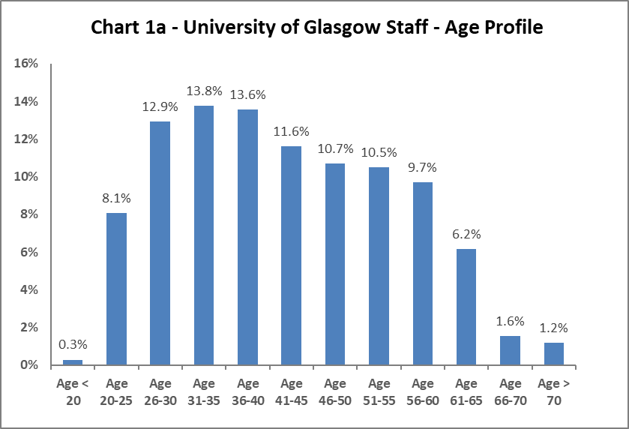

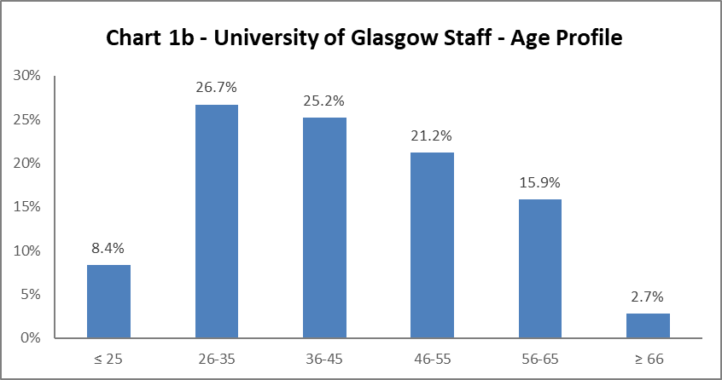

The University's age profile follows more or less a bell curve, as shown in Charts 1a and 1b above. The age profile has remained similar since 2011-12. There has been a slight increase in 20-25 years since 2018-19, by 0.5%. The only other notable change is in the 51-55 age range which has dropped by 0.8% since 2018-19.

## Disability

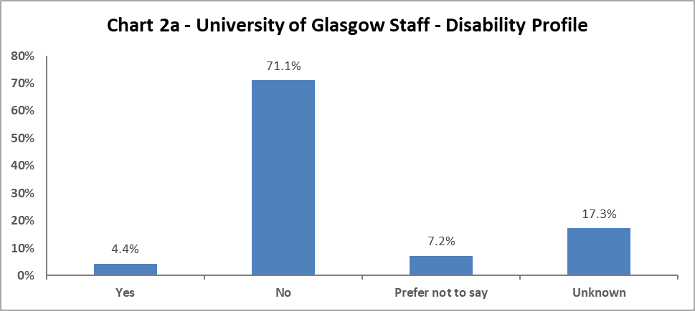

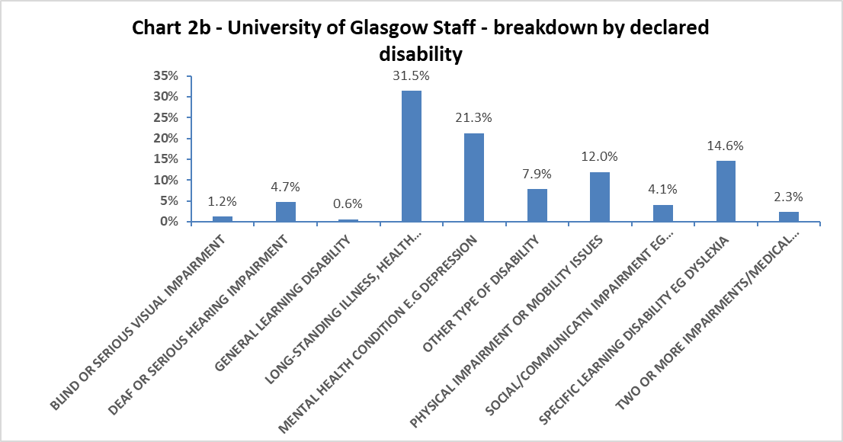

Chart 2a above shows 4.4% of University staff have declared a disability, this is static from 2018-19. However, since 2018-19 there has been an increase in the Unknown from 13.8% to 17.3%, and a decrease in staff stating ‘No’ by 2.5% and a 1% decrease in those stating, ‘prefer not to say’. This implies staff are not completing this data, and the University needs to consider how to support declarations.

When considering impairment type, in Chart 2b, the largest cohort of staff has a longstanding illness or health condition, and this has increased by 1.7% from 2018-19. Comparing to 2018-19 also shows an increase by 1.5% of those with a physical impairment or mobility issues, and 0.9% increase in those with a social/communication impairment and a specific learning disability. All other impairment types have only marginal increases or decreases.

## Marital Status

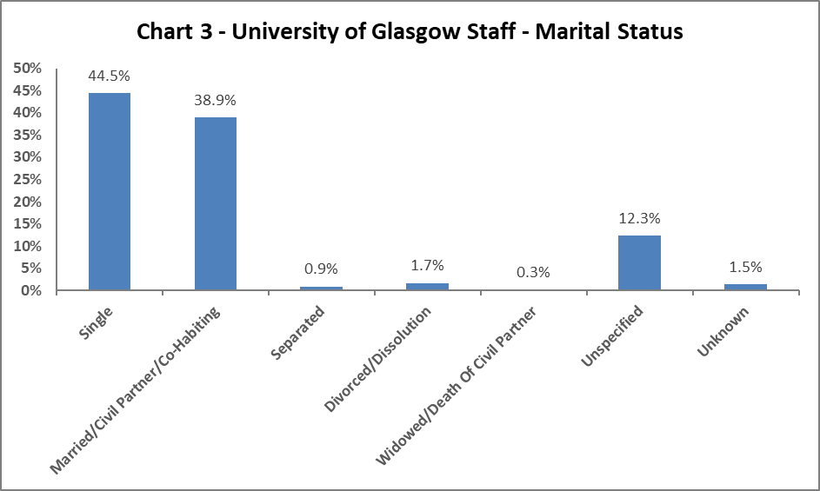

Chart 3 shows single staff represent 44.5% of the staff population. This has risen steadily from 31.5% in 2013-14, with a corresponding drop (from 52.1% to 38.9%) in Married/Civil Partnership/Co-habiting staff. This is the first year we have more single staff than Married/Civil Partner/Co-Habiting.

## Full Time/Part Time

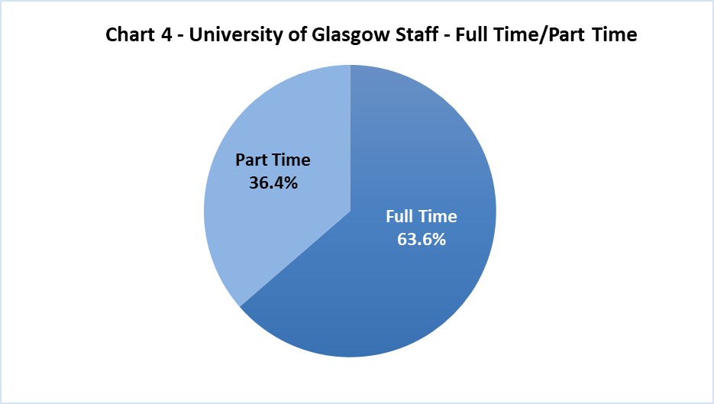

Chart 4 shows approximately two thirds of University staff working full time and one third working part time. The Part Time staff continue to grow with an increase of 0.9% from 2018-19.

## Nationality

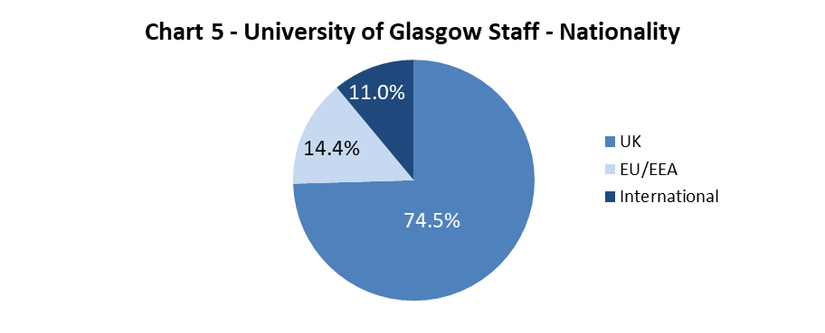

The data shows a 0.5% increase in staff from International backgrounds. The EU/EAA staff are static from 2018-19, and a 0.6% drop in UK staff since 2018-19.

## Ethnicity

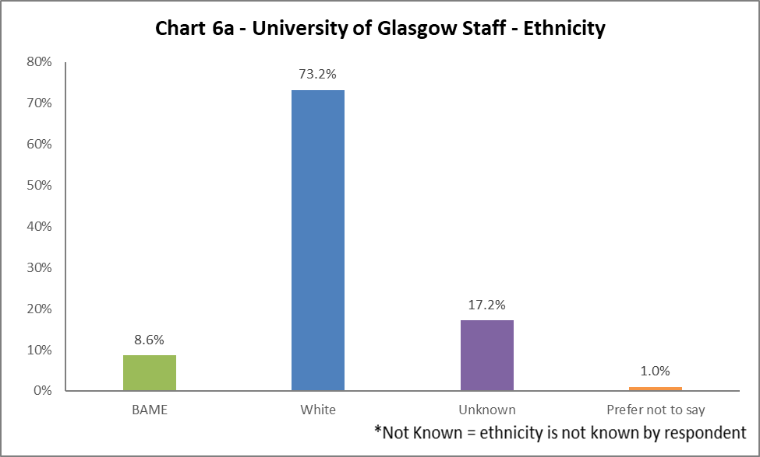

Chart 6a shows 8.6% of University staff are from a Black, Asian or Minority Ethnic (BAME) background, a 0.1% decrease from 2018-19. There has been a 3.1% decrease in staff stating they are White and a 4.1% increase in the ‘Unknown’ category. This implies staff are not completing this data, and the University needs to consider how to support declarations. The full ethnic breakdown is provided in Chart 6b on the next page.

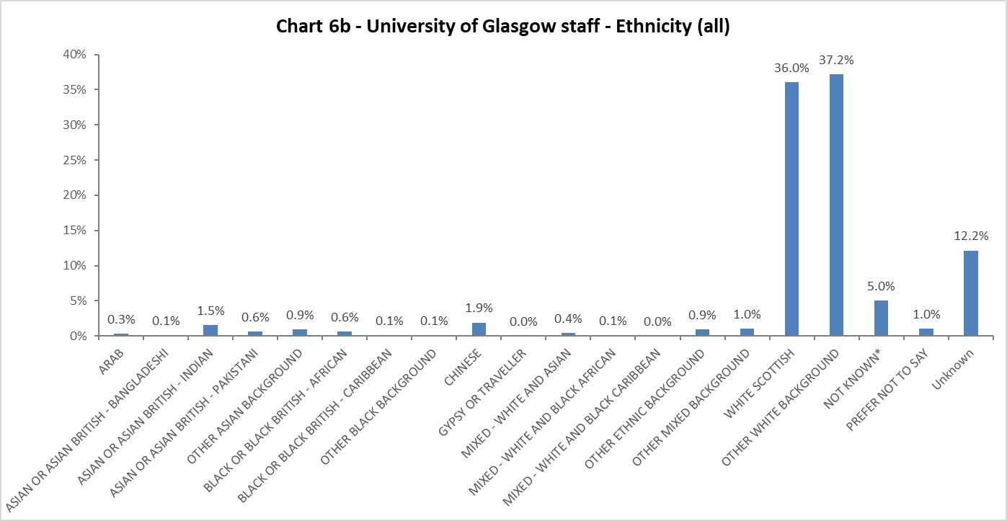

## Religion and Belief

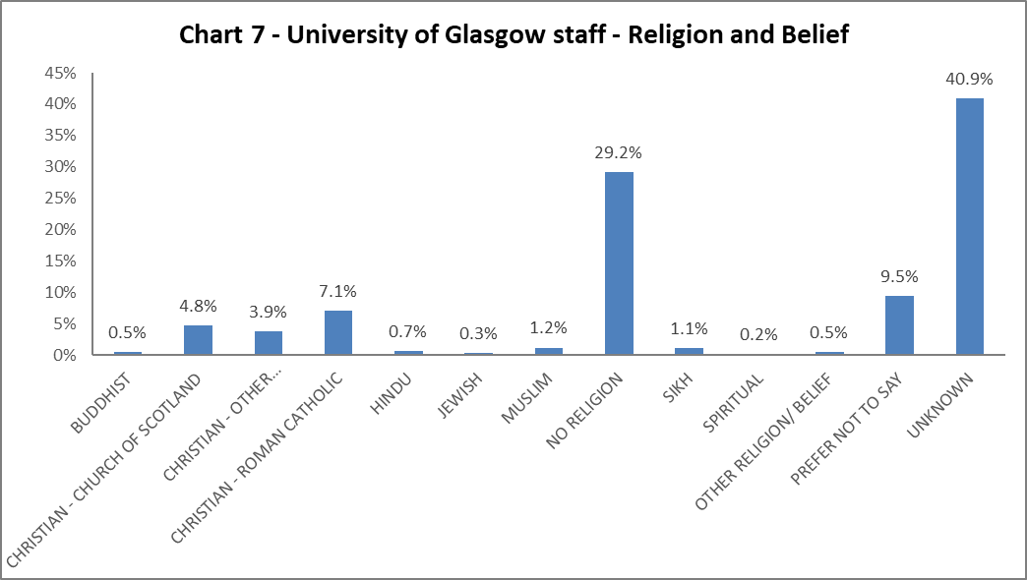

The largest component of staff continues to state they have no religion. There has been a slight rise in staff stating they are Christian by 0.4%, with the largest proportion stating they are Roman Catholic.

## Sex

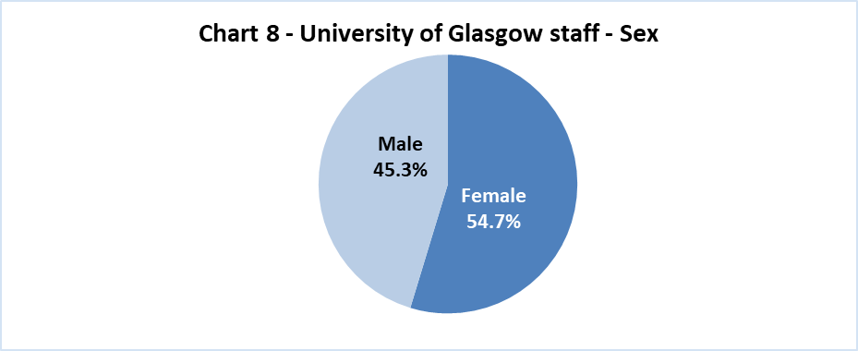

Chart 8 shows the proportion of staff by Sex, this is unchanged from 2018-19.

## Sexual Orientation

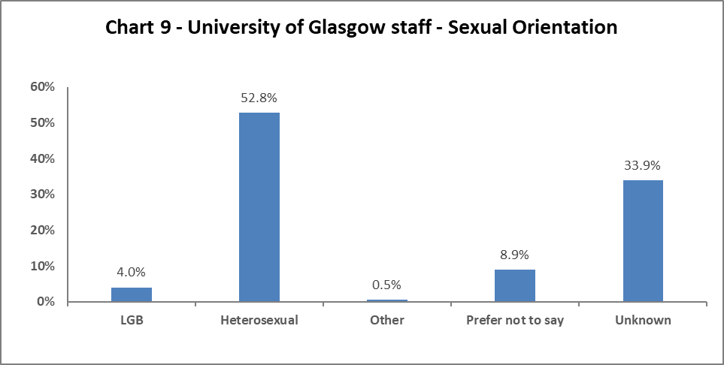

2019-20 has seen a 0.1% increase in staff declaring they are Lesbian, Gay or Bisexual. There has been a 1.4% decrease in staff stating they are Heterosexual and a 1.1% increase in the ‘Unknown’ category.

## Maternity Leave

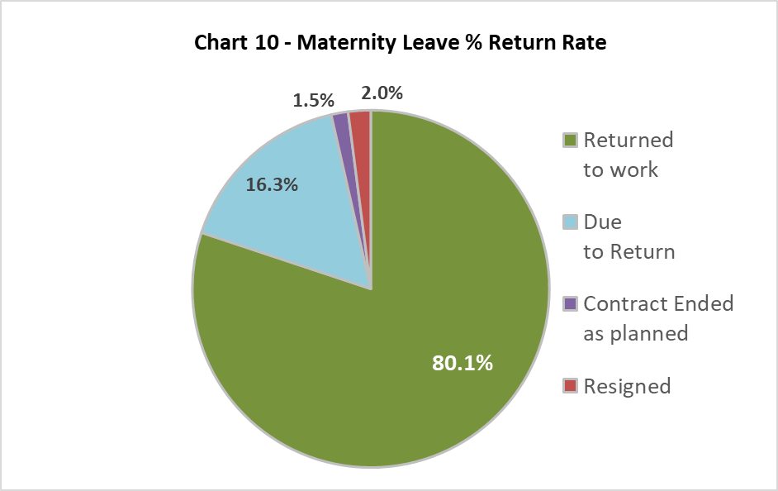

80.1% of staff returned from maternity leave during 2019-20, this is a significant increase from 2018-19 – however there was a larger proportion still on maternity leave and due to return in that period (38%). There has been a drop in the percentage of staff whose contract ended as planned this year from 4.1% in 2018-19 to 1.5% in 2019-20.

## Gender Reassignment

23 staff responded negatively to the gender identity question:

‘Is your gender identity the same as the sex registered at birth?’

# Profile by Age

## By College

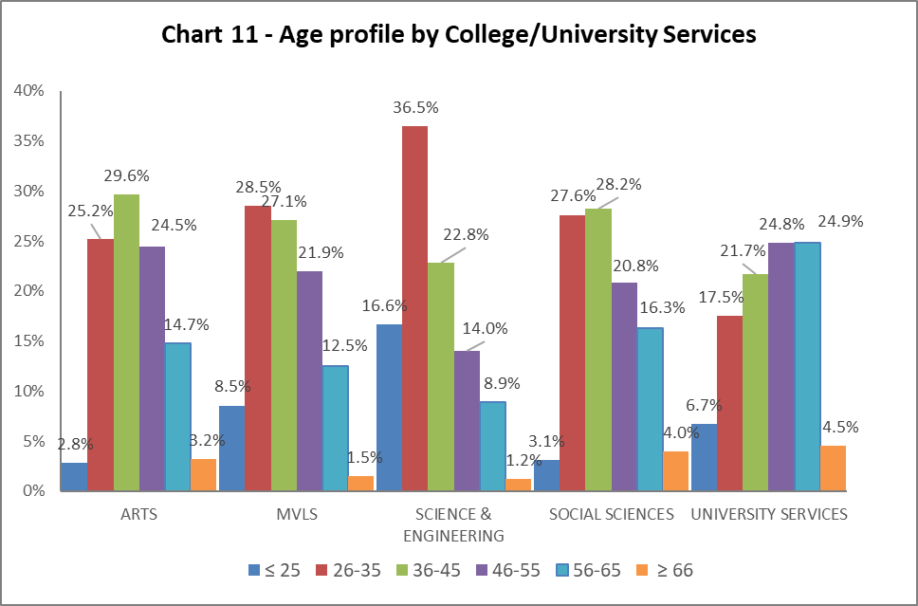

|  |  |  |  |  |  |
| --- | --- | --- | --- | --- | --- |
| Table 7 | ARTS | MVLS | SCIENCE & ENGINEERING | SOCIAL SCIENCES | UNIVERSITY SERVICES |
| Age Range | **%** | **%** | **%** | **%** | **%** |
| ≤ 25 | 2.8 | 8.5 | 16.6 | 3.1 | 6.7 |
| 26-35 | 25.2 | 28.5 | 36.5 | 27.6 | 17.5 |
| 36-45 | 29.6 | 27.1 | 22.8 | 28.2 | 21.7 |
| 46-55 | 24.5 | 21.9 | 14.0 | 20.8 | 24.8 |
| 56-65 | 14.7 | 12.5 | 8.9 | 16.3 | 24.9 |
| ≥ 66 | 3.2 | 1.5 | 1.2 | 4.0 | 4.5 |

Chart 11 above allows a quick visualisation of the distribution of ages in each College/US which can be compared with the Whole University distribution in Chart 1. Table 7 above gives the relevant percentages. The College of Arts has seen a 3.6% increase in 26-35 year olds and a decrease of 2.4% in 36-45 year olds, and reflects a progressive increase in younger staff in the College. All other Colleges/US have only seen slight fluctuations in the age ranges of staff. College of Science and Engineering continues to have significant percentage of 26-35 year olds at 36.5%, and US continues to have the oldest population of staff.

## By Grade 10 staff

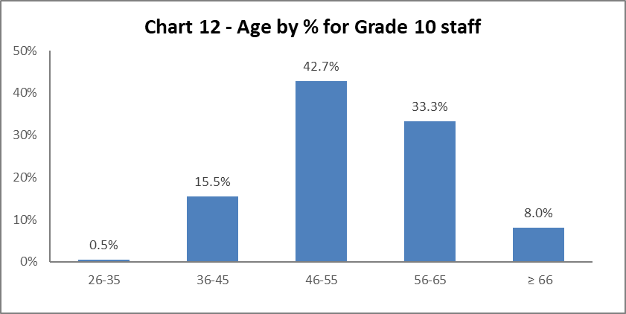

Chart 12 above shows the majority of Grade 10 staff are aged 46 or over. There has been a 2.3% increase staff under 45 years old in Grade 10 since 2018-19.

## By Job Family Profile

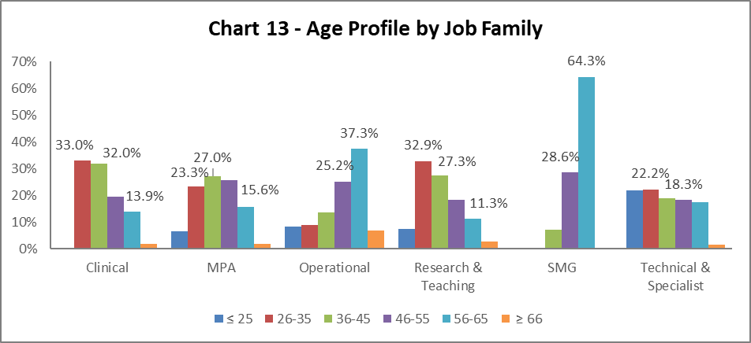

|  |  |  |  |  |  |  |
| --- | --- | --- | --- | --- | --- | --- |
| Table 8 | Clinical | MPA | Operational | Research & Teaching | SMG | Technical & Related |
| Age Range | **%** | **%** | **%** | **%** | **%** | **%** |
| Age ≤25 | 0.0 | 6.6 | 8.3 | 7.3 | 0.0 | 21.8 |
| Age 26-35 | 33.0 | 23.3 | 9.0 | 32.9 | 0.0 | 22.2 |
| Age 36-45 | 32.0 | 27.0 | 13.5 | 27.3 | 7.1 | 19.0 |
| Age 46-55 | 19.4 | 25.7 | 25.2 | 18.4 | 28.6 | 18.3 |
| Age 56-65 | 13.9 | 15.6 | 37.3 | 11.3 | 64.3 | 17.3 |
| Age ≥66 | 1.7 | 1.8 | 6.8 | 2.8 | 0.0 | 1.4 |

Chart 13 above outlines the age distribution by job family. The MPA under 25 years old cohort has seen a significant decrease in the last year, however this will be relatively low in number. The Operational job family continues to be older, however there is improvement in numbers at a younger age range. This is markedly noticeable in the Technical and Related job family, which has seen a 10% increase in staff who are under 25. Table 8 above gives the relevant percentage figures.

## By Grade

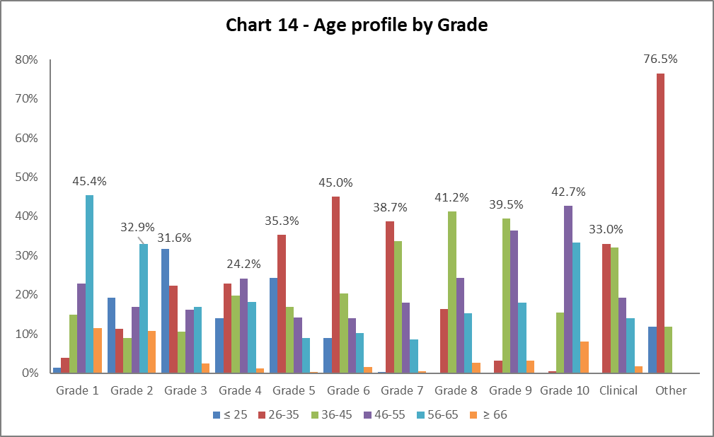

|  |  |  |  |  |  |  |  |  |  |  |  |  |
| --- | --- | --- | --- | --- | --- | --- | --- | --- | --- | --- | --- | --- |
| Table 9 | Grade 1 | Grade 2 | Grade 3 | Grade 4 | Grade 5 | Grade 6 | Grade 7 | Grade 8 | Grade 9 | Grade 10 | Clinical | Other |
| Age Range | **%** | **%** | **%** | **%** | **%** | **%** | **%** | **%** | **%** | **%** | **%** | **%** |
| Age ≤ 25 | 1.4 | 19.3 | 31.6 | 14.0 | 24.4 | 9.0 | 0.3 | 0.1 | 0.0 | 0.0 | 0.0 | 11.8 |
| Age 26-35 | 3.9 | 11.3 | 22.3 | 22.8 | 35.3 | 45.0 | 38.7 | 16.4 | 3.1 | 0.5 | 33.0 | 76.5 |
| Age 36-45 | 14.9 | 8.9 | 10.5 | 19.8 | 16.9 | 20.2 | 33.7 | 41.2 | 39.5 | 15.5 | 32.0 | 11.8 |
| Age 46-55 | 22.8 | 16.9 | 16.2 | 24.2 | 14.2 | 13.9 | 18.1 | 24.3 | 36.4 | 42.7 | 19.3 | 0.0 |
| Age 56-65 | 45.4 | 32.9 | 16.9 | 18.1 | 8.9 | 10.3 | 8.6 | 15.2 | 17.9 | 33.3 | 14.0 | 0.0 |
| Age ≥ 66 | 11.5 | 10.7 | 2.5 | 1.2 | 0.4 | 1.6 | 0.5 | 2.7 | 3.1 | 8.0 | 1.7 | 0.0 |

Chart 14 and Table 9 show the general profile for age range reflects the norm and has not changed significantly since reporting started. However, there are increases of over 1% in Grades 1 and 2 for age range 66+. There is a significant rise in age range 26-35 from Grade 6; which coincides with the start of the Research and Teaching job family.

## By Full/Part Time

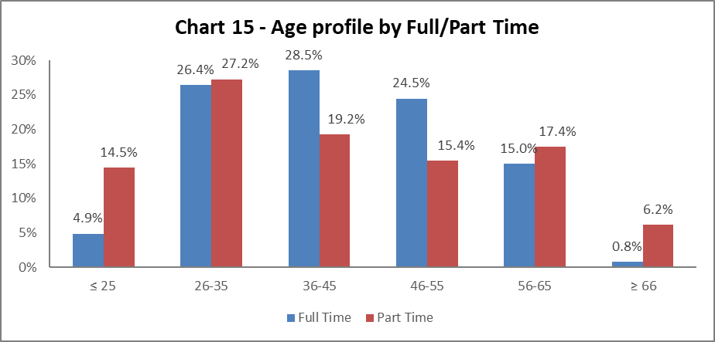

Chart 15 shows the part time staff age profile. A larger proportion of staff under 35 work part time than full time – this is a change from 2018-19.

## By Contract Type

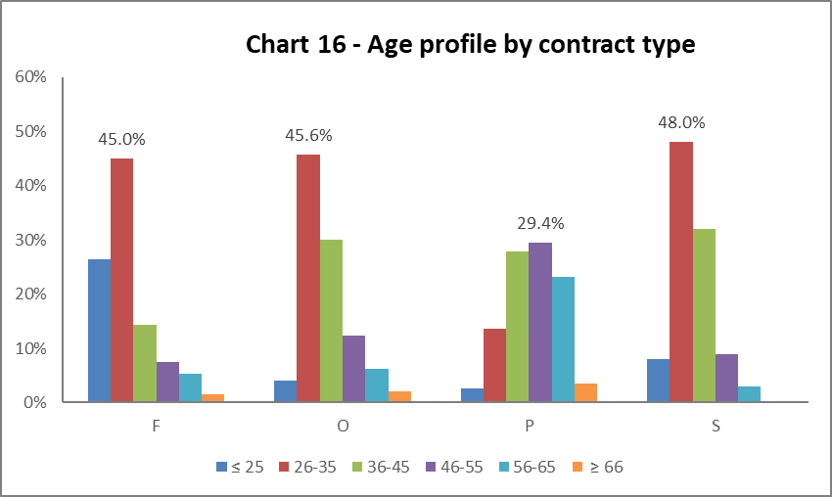

**Key**

F = Fixed term as per FT & OE Contract policy

O = Open ended with funding end date

P = Open ended (‘Permanent’) + Perm in Temp Fixed Term Appointment (HoC/Principal/VP role)

S = Fixed term - SOSR e.g. Maternity leave cover

|  |  |  |  |  |
| --- | --- | --- | --- | --- |
| Table 10 | F | O | P | S |
| Age Range | **%** | **%** | **%** | **%** |
| Age ≤25 | 26.4 | 4.0 | 2.6 | 8.0 |
| Age 26-35 | 45.0 | 45.6 | 13.6 | 48.0 |
| Age 36-45 | 14.4 | 30.0 | 27.8 | 32.0 |
| Age 46-55 | 7.4 | 12.3 | 29.4 | 9.0 |
| Age 56-65 | 5.3 | 6.1 | 23.1 | 3.0 |
| Age ≥66 | 1.5 | 2.0 | 3.5 | 0.0 |

Chart 16 above shows that Open ended with Funding End Date (code O) and both types of Fixed Term (F & S) workers are generally younger (under 35). The percentage of staff on (code O) has decreased by 1.4% from 2018-19. Staff on Open ended contracts (code P) tend to be older compared to the University profile. The Fixed term contracts (code S) are relative few in number, hence the spike in age range 26-45 years.

## By Nationality

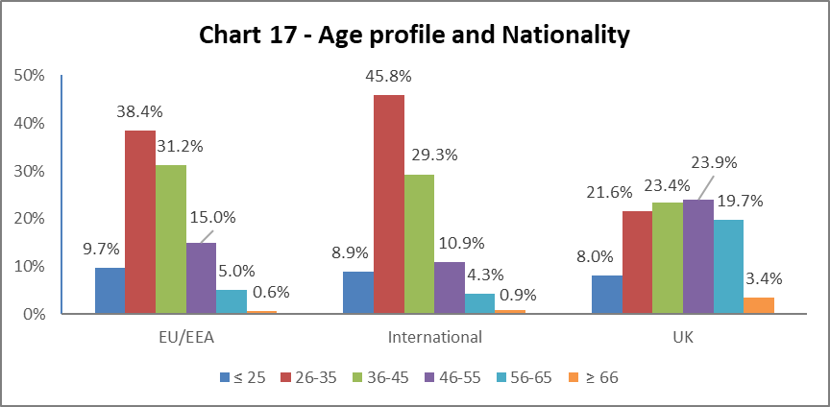

Chart 17 tells us a higher percentage of our EU/EEA and International staff are younger than our UK staff, this reflects the last four years data.

## Recruitment – by Applications and Successful Applicants

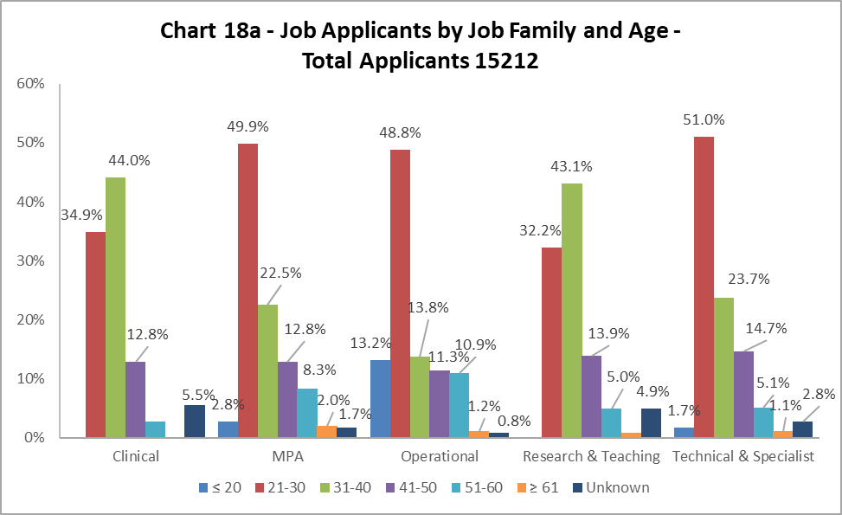

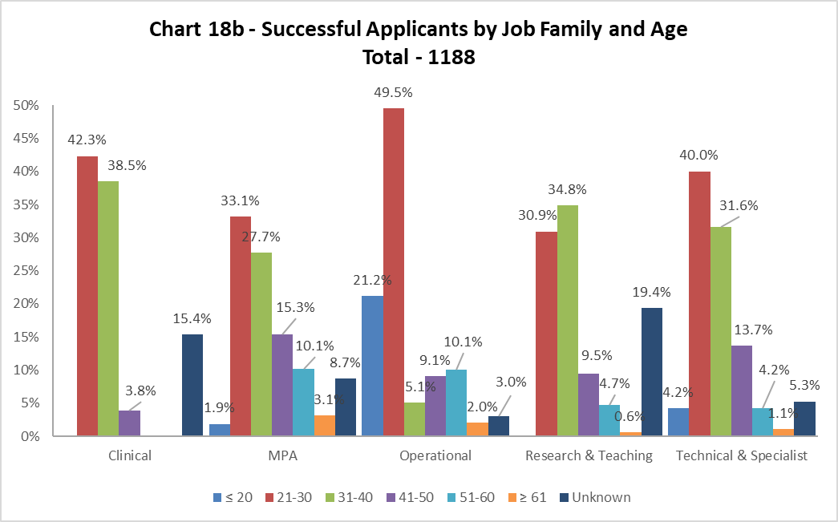

As in previous years, Charts 18a and 18b show the age of applicants are generally reflective of the appointments. The biggest disparities are in the Operational job family, where under 20 where more successful and 31-40 yar olds were less successful. The data displays unknowns for the first time.

# Profile by Disability

## By College

## Chart 19 - Disability by College. In order of declared disability University Services has 5.5%, the College of Social Sciences has 4.7%, MVLS has 4.3%, Arts has 3.8% and Science and Engineering has 3.0%. There are high rates of non-disclosure across the University.

Chart 19 shows the percentage of Disabled staff within College/US. There has been a slight increase in staff with disabilities in Science & Engineering and University Services (by 0.1% and 0.5% respectively). All other areas have seen a drop in disability declarations – most notably in Arts by 1.8%. The ‘Unknown’ category is the second highest in all Colleges/US, behind ‘No’, this requires significant focus by the University.

## By Grade 10 staff

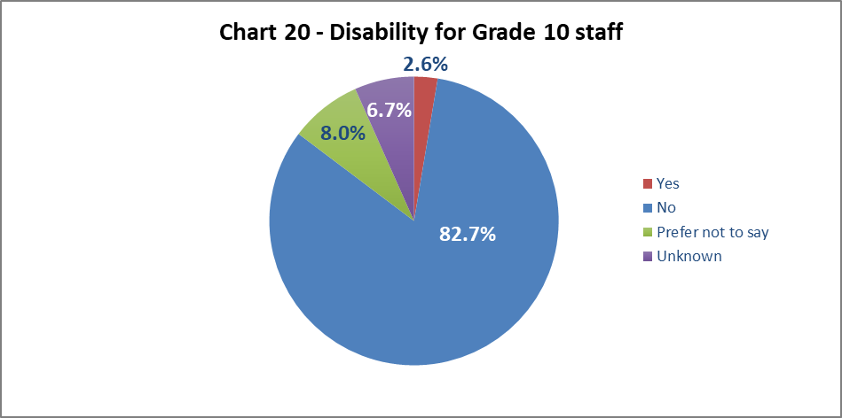

Chart 20 shows 2.6% of senior staff have declared a disability; this is a 0.4% decrease from 2018-19, and is lower than the University wide figures.

## By Job Family Profile

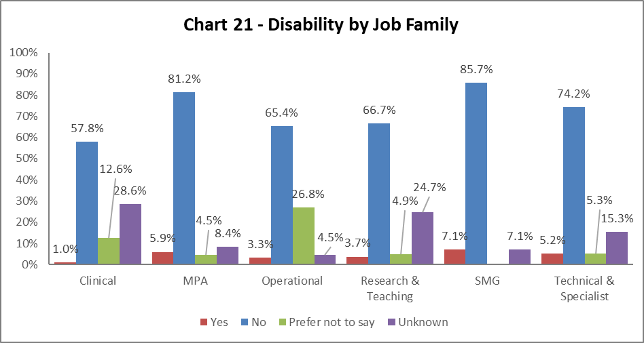

Chart 21 shows most job families have seen minor fluctuations in disability declaration rates from 2018-19. Most notable is the significant percentage of ‘Unknown’ in Clinical, Research & Teaching and Technical & Specialist staff. In addition, one quarter of all Operational staff have stated ‘Prefer not to say’.

## By Grade

Chart 22 shows disability declaration rates by Grade. There has been a 1% decrease in Grade 3 staff declaring a disability, and minor fluctuation in all declaring grades from 2018-19. However, there are almost 40% of Grade 1 staff stating, ‘Prefer not to say’ and significantly high percentage of Grades 3, 5,6, and Clinicians as ‘Unknown’.

## By Full/Part Time

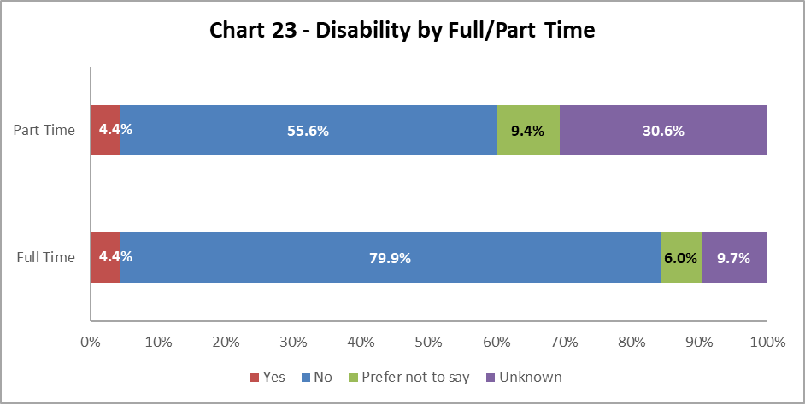

Chart 23 shows staff with a disability are equally as likely to work full time or part time. There has been a rise in the ‘Unknown’ category in both full and part time since 2018-19.

## By Contract Type

Chart 24 above shows Disabled staff are most likely to have an SOSR contract (code S) – but as this is only 1.2% of the staff population this is very low. The next highest is Open-ended with funding end date (code O) contract, which is 0.5% higher than 2018-19. In general, there has been an increase in Disabled staff in all contract types. However, has been a rise in Disabled staff with Open-ended (code P) from 3.3% in 2015-16, to 4.5% in 2019-20. Again, there large proportions of ‘Unknown’ in all contract types, significantly in Fixed Term staff at 50.5%.

## By Nationality

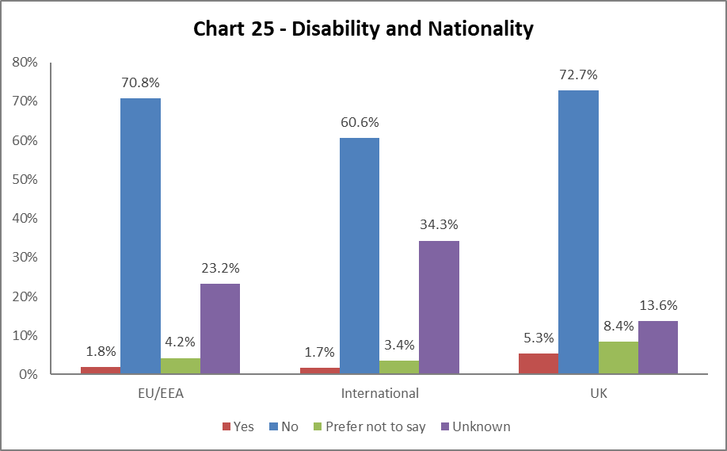

Chart 25 indicates a higher percentage of staff from the UK have declared a disability, this is static from 2018-19. International and EU/EEA staff have significant ‘Unknown’ rates.

## BSL Users

As part of the University’s British Sign Language (BSL) Action Plan we have reviewed the number of staff who declared a level of proficiency in the use of BSL. Less than 5 staff have declared any level of proficiency.

## Recruitment – by Applications and Successful Applicants

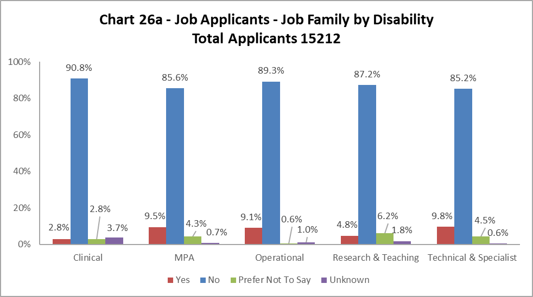

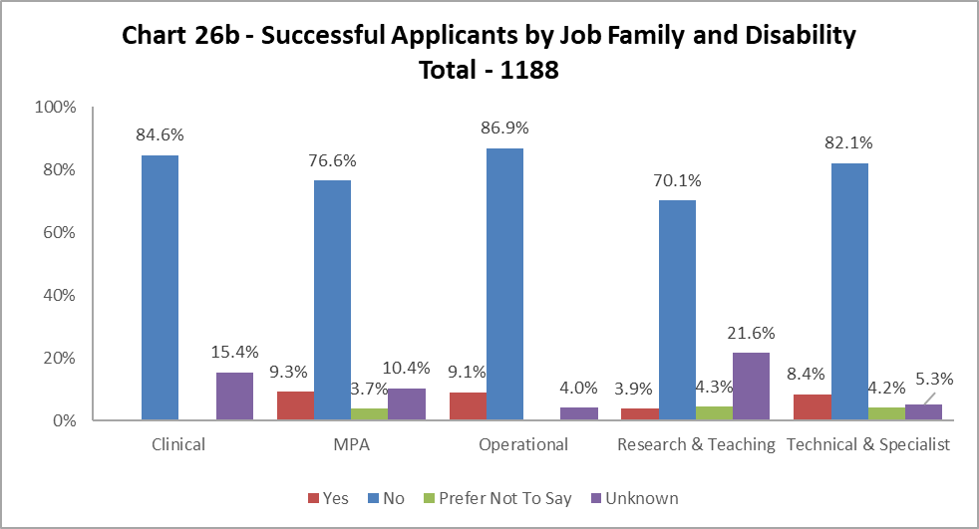

Charts 26a and 26b show that across most job families had slightly more Disabled applicants than were successfully appointed, however the differences were very small. The only exception was Clinical where no Disabled staff were successful, however the numbers will be small in this job family. There are significantly high percentages of ‘Unknown’ in the Research & Teaching job family.

# Profile by Ethnicity

## By College

## Chart 27 - Ethnicity by College/University Services. Science and Engineering has 14.2% of staff declared as 'BAME' however they also have the highest rate of non-disclosure at 27.5% between 'Unknown/Blank' and 'Prefer Not to Say'. Social Sciences has 11.7% 'BAME', with University Services with the lowest proportion of declared 'BAME' ethnicity at 4.6%.

Chart 27 shows the breakdown by ethnicity of staff in College/US. There have been minor fluctuations in the percentage across all Colleges, most notably a drop in Arts from 5.3% in 2018-19 to 4.9% in 2019-20; US percentage is static. There has been a growth in all Colleges/US in the percentage of ‘Unknown’ ethnicity.

## By Grade 10 Staff

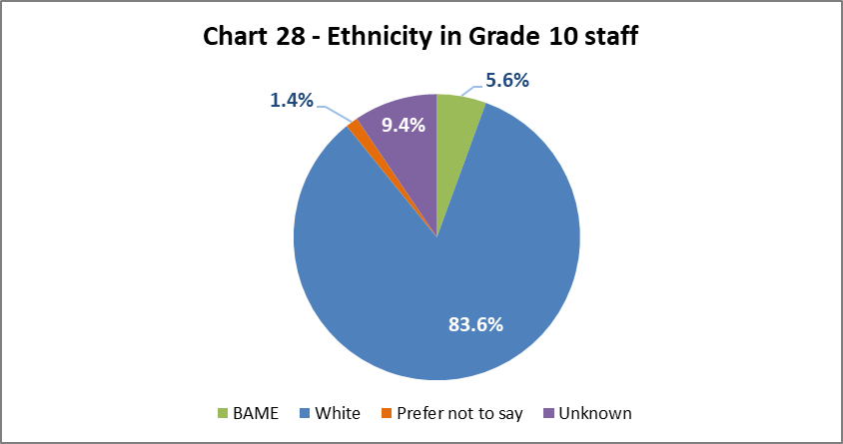

Chart 28 above show the ethnicity of staff at Grade 10. The has been a minor increase in BAME staff at this grade from 5.4% in 2018-19 to 5.6%.

## By Job Family Profile

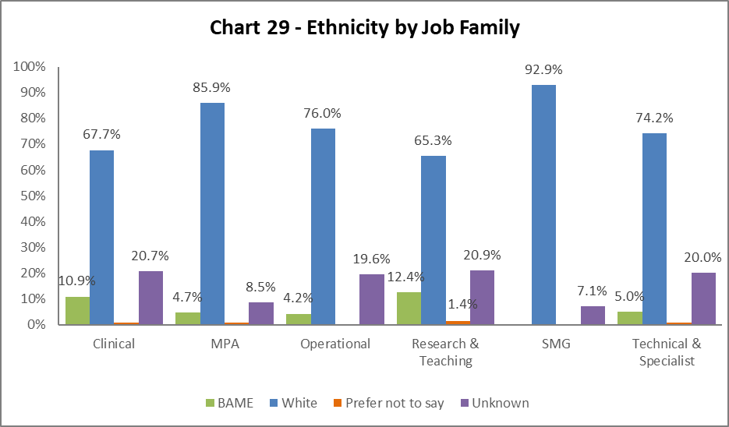

Chart 29 shows the ethnicity of staff by job family. There have only been minor fluctuations in BAME staff across the job families since 2018-19, except for MPA which has seen a drop from 5.5% in 2018-19 to 4.7%. Notably, there are high percentages of ‘Unknown’ across all the job families.

## By Grade

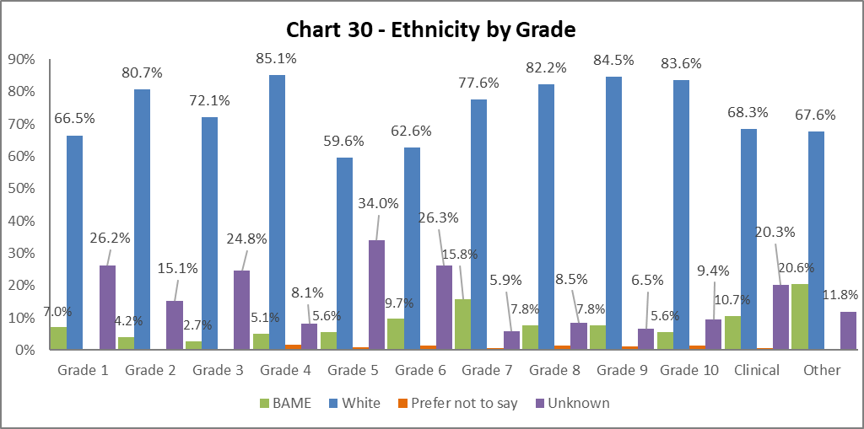

Chart 30 above shows the grade and ethnicities of staff. There is a differing picture across the grades with rises of 0.5% or more in Grades 7 and 9, but equivalent drops in Grades 2, 4, 6 and 8, between 2018-19 and 2019-20. In general the ‘Unknown’ category is higher in Grades 6 and below.

## By Full/Part Time

## Chart 31 -Ethnicity Profile by Part Time/Full Time roles. Of staff in a Full Time role, 9.5% are form a 'BAME' background, compared with 7.0% in Part Time roles. We have no information on the ethnicity of 30.4% of our Part Time staff.

The ethnicity of staff working full time and part time reflects the 2018-19 data, however there are rises in the ‘Unknown’ category for both modes of working.

## By Contract Type

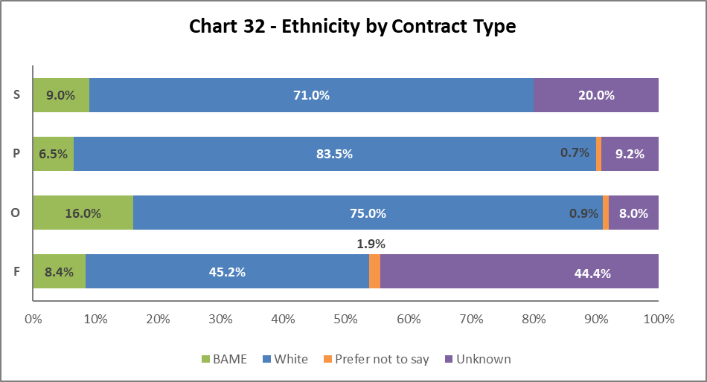

Chart 32 indicates the highest proportion of BAME staff are on Open-ended with funding end date (code O) contracts, an increase of 2% from 2017-18. All contract types have seen an increase in the percentages of BAME staff compared to last year. The percentage of staff on contract type F with ‘Unknown’ ethnicity has increased by more than 10% from 2018-19.

## By Nationality

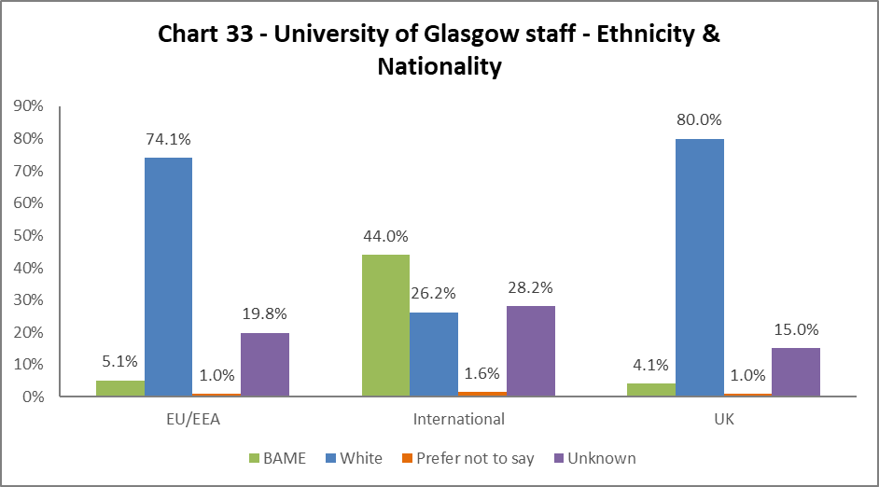

Chart 33 outlines the nationality and ethnicity of our staff. 44% of our International staff and 5.1% of our EU/EAA staff are from BAME backgrounds. Of our UK staff, only 4.1% are from BAME backgrounds – a 0.1% increase from 2018-19.

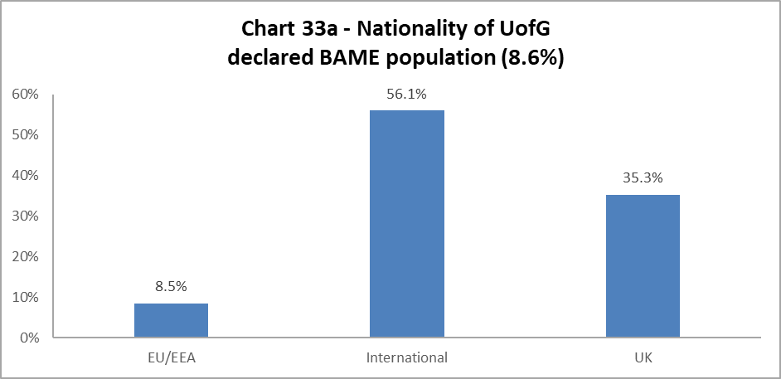

Chart 33a is a new inclusion for this report. The chart outlines the nationality of our BAME staff population (8.6% of total – see Chart 6a). Over half of our total BAME staff are International, with slightly over one third from the UK and 8.5% from the EU/EEA.

## Recruitment – by Applications and Successful Applicants

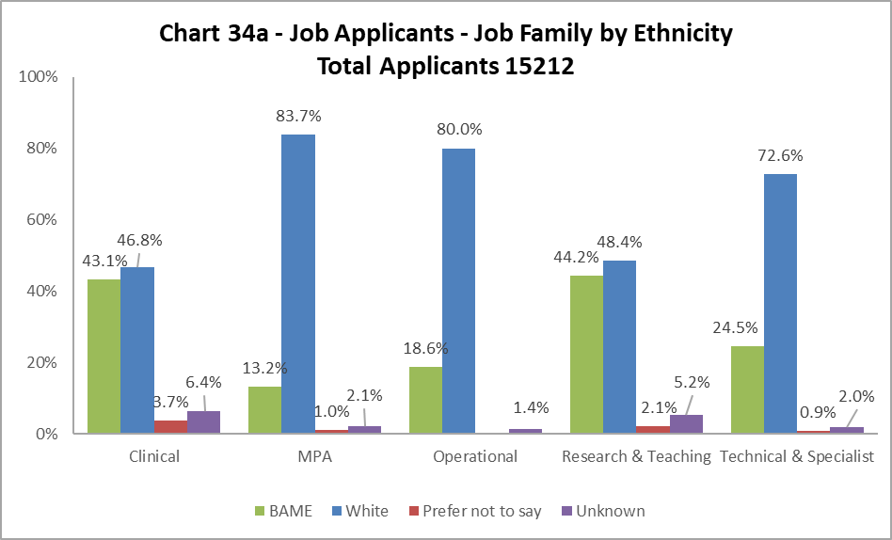

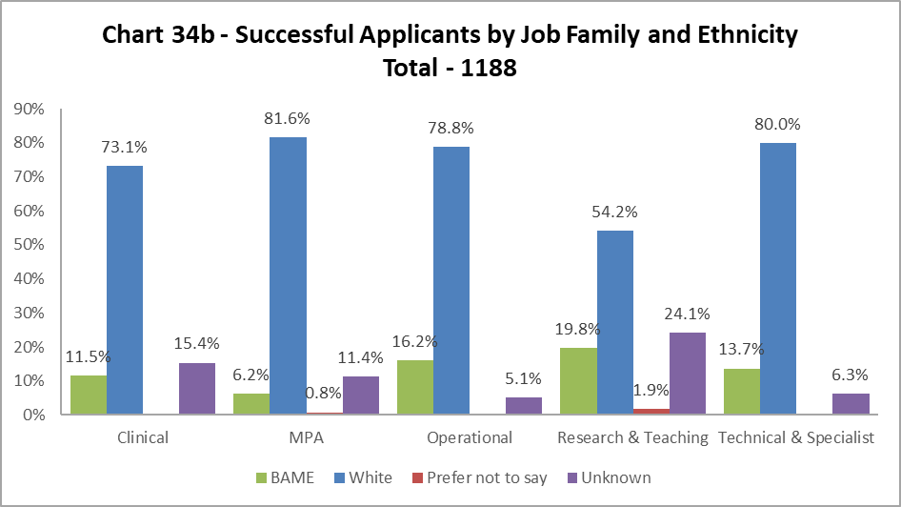

The data, as illustrated by Chart 34a and 34b, shows BAME staff are proportionally less likely to be appointed in all job family profiles. The greatest difference is seen in the Clinical job family, where the drop between applications and successful applicants is over 30% - it should be noted there will be a relatively low number of jobs advertised in this job family. The drop in Research and Teaching between applications and successful appointments had reduced to under 10% in 2018-19 but is once again larger than 20% in 2019-20.

# Profile by Sex

## By College

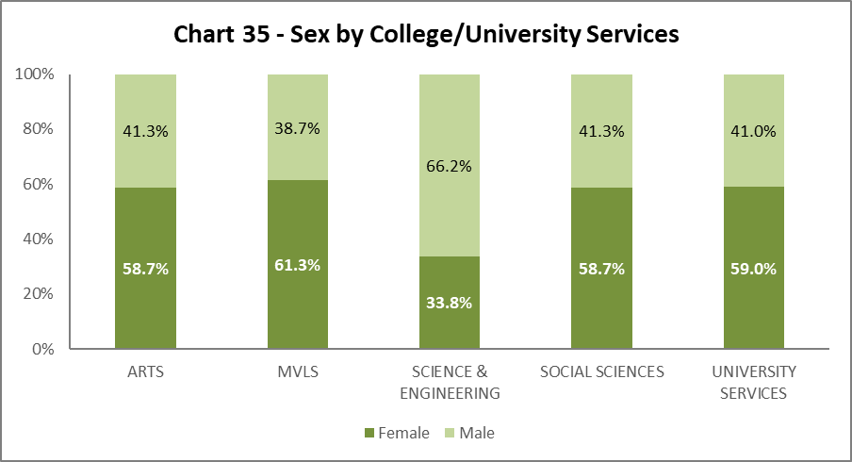

Chart 35 shows the split by Sex in College/US. Arts has seen a slight drop in the percentage of Males, whilst Social Science and US have seen minor increases in Females. All other areas are static.

## By Grade 10 Staff

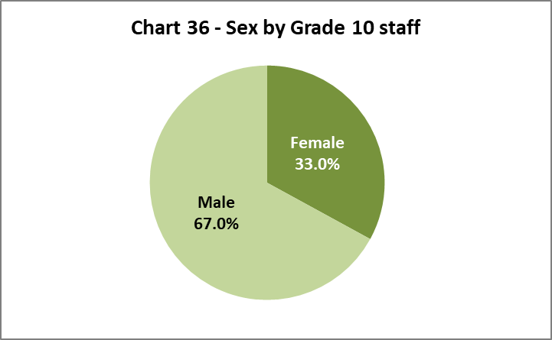

Chart 36 illustrates that 33% of senior staff are Female. This is an increase of 2.2% from 2018-19 and therefore the University has achieved its Key Performance Indicator (KPI), of 33%[3] by 2020.

## By Job Family Profile

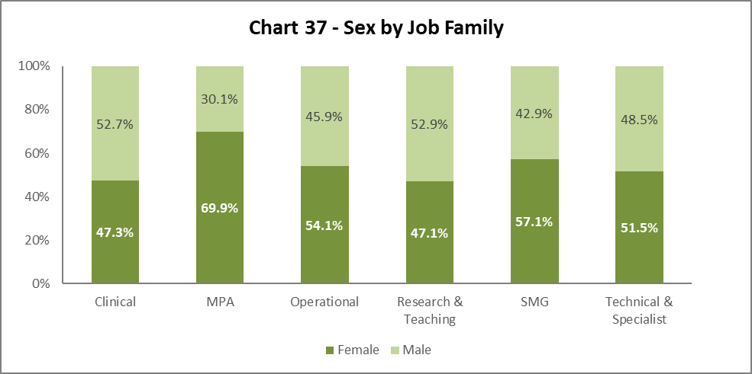

Chart 37 shows a further increase in Females in SMG by 3.8% from 2018-19. There are other minor fluctuations across the job families – an increase in females in Clinical, MPA and Research and Teaching job families.

## By Grade

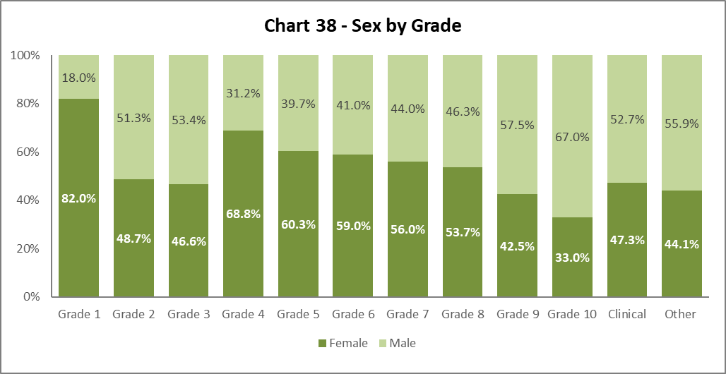

Chart 38 shows a similar pattern to previous years (with the exception of Grades 2 and 3, where there are almost 50:50 splits) as we climb the grades, the percentage of Male staff increases, and Female staff declines. The percentage of Females in Grade 4 has dropped by 3.5%, Grade 8 Females has increased by 1.7%.

## By Full/Part Time

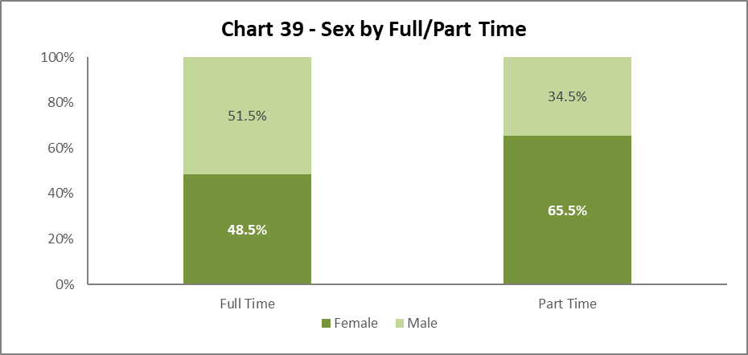

Chart 39 illustrates the breakdown by Sex of Full and Part Time staff, this is a static picture from 2018-19, where approximately two thirds of all Part Time staff are Female.

## By Contract Type

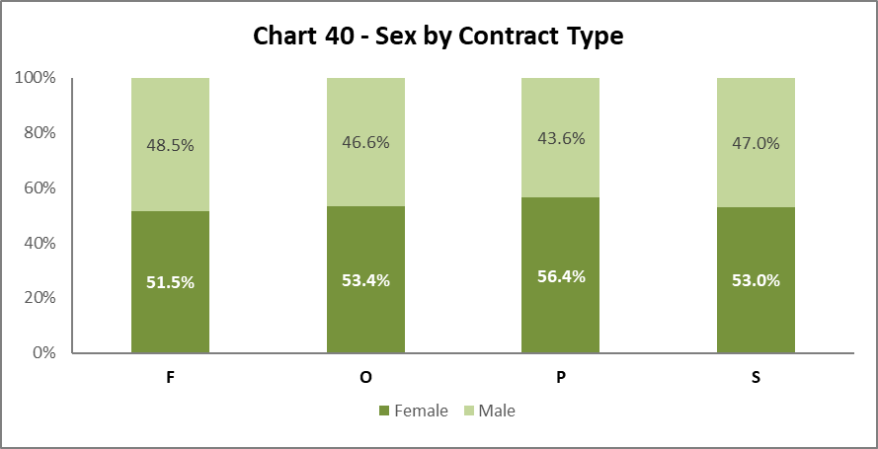

Chart 40 shows Sex by contract type. There is very little change from 2018-19, except for contract type S, where the balance is more even between Males and Females than last year.

## By Nationality

**Chart 41 - Sex by Nationality. 
EU/EEA - 52.5% Female, 47.5% Male.
International - 45.5% Female, 54.5% Male.
UK - 56.5% Female, 43.5% Male**

Chart 41 shows Females and Males are fairly equally represented from EU/EEA. We have a higher proportion of Male International staff, although the Female percentage has increased by 2% from 2018-19.

## Recruitment – by Applications and Successful Applicants

**Chart 42a - Job Applicants (#15212) by Sex and Job Family. 
Clinical 46.3% Female 53.7% Male
MPA 67.7% Female, 31.2% Male. 1.1% Prefer not to say (PNTS)
Operational - 59.5% Female, 38.9% Male, 1.6% PNTS
Research & Teaching - 38.9% Female, 59.9% Male, 1.2% PNTS
Technical & Specialist - 44.8% Female, 53.9% Male, 1.2% PNTS
**

For most job families, the Sex profile of applicants reflects those who are successful applicants, however in Research and Teaching, Males are proportionately more successful than Female, and this is reverse of 2018-19. Females are more successful than Males in the Technical and Specialist job family.

# Profile by Sexual Orientation

33.9% of all staff have not answered the question on Sexual Orientation. As such ‘Unknown’ figures have been excluded from these graphics but have been included in the statistics which are used to create them.

## By College

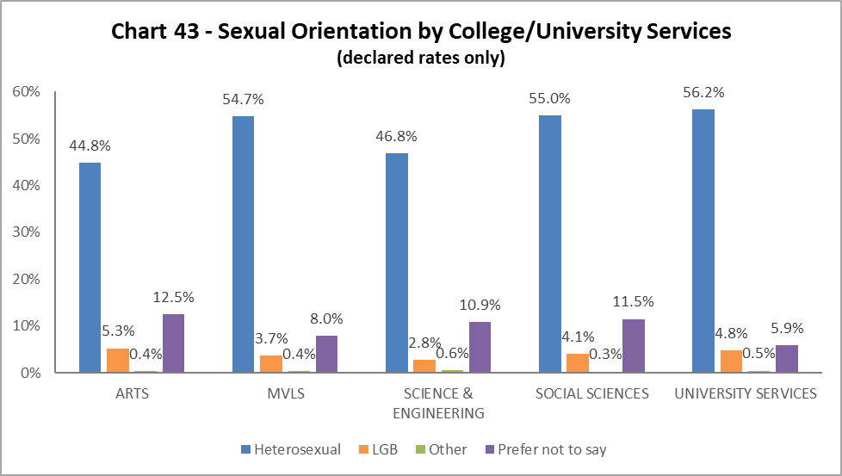

Arts continue to have the highest proportion of staff who have declared as LBG compared to other Colleges/US; Science and Engineering has the smallest proportion. There have been minor fluctuations across all Colleges/US from 2018-19.

## By Grade 10 Staff

## Chart 44 - declared Sexual Orientation for Grade 10 staff. Staff who have not answered the question have been excluded from the graph. 48.9% have declared as heterosexual. 3.3% of Grade 10 staff have declared as 'LGB'. 49.7% have declared as Heterosexual. 8.5% have chosen the 'Prefer not to say' option and 0.5% have chosen the 'Other' option.

3.3% of Grade 10 staff identify as LGB, this is an increase of 0.3% from 2018-19.

## By Job Family

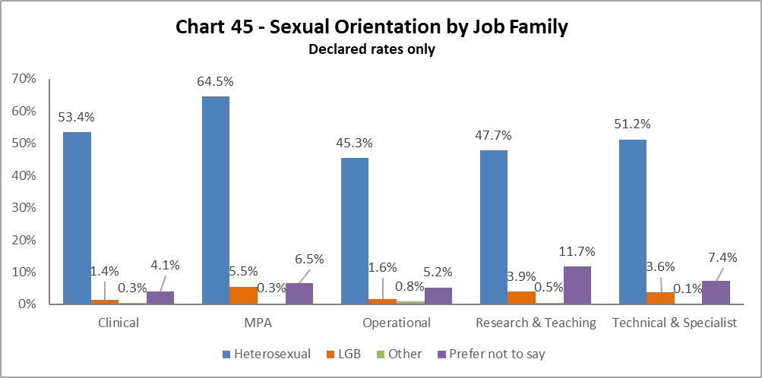

The highest proportion of LGB staff (5.5%) are in the MPA job family, an increase of 1.8% from 2017-18, all other job families have seen minor fluctuations from 2018-19.

## By Grade

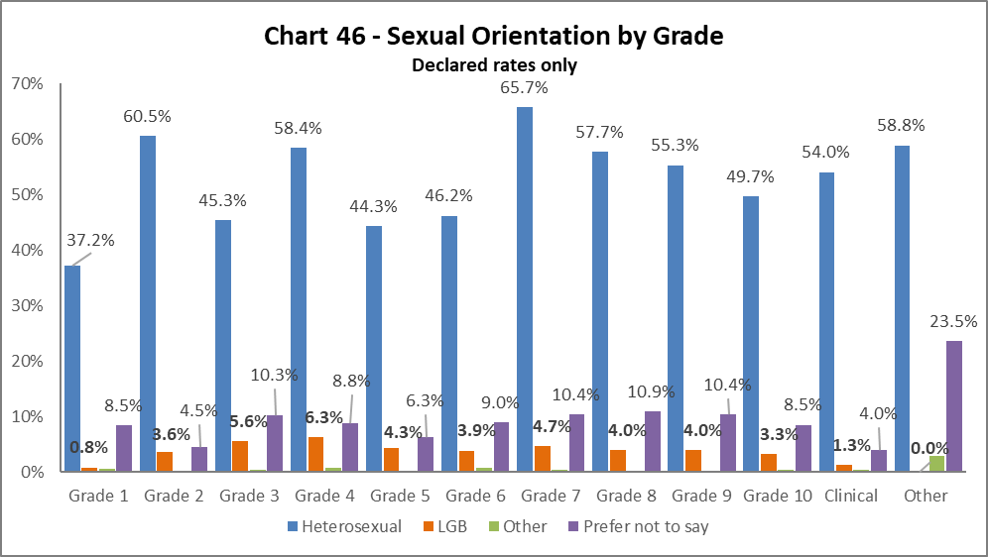

LGB staff are evenly spread across the grades, with the highest proportion in Grade 4. There have been slight fluctuations across the grades, increases in Grades 3, 4, 5, 7 and 8 and decreases in Grades 1, 2, 6 and 9.

## By Full/Part Time

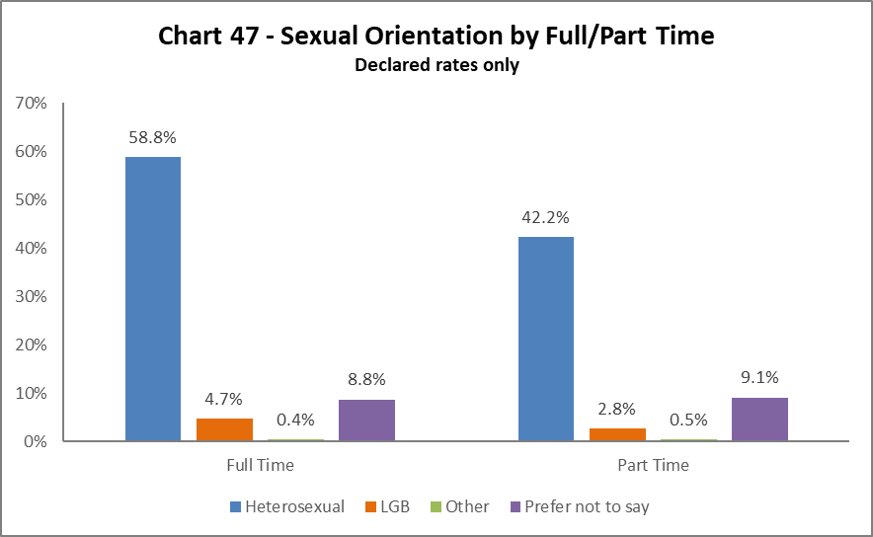

Most LGB staff work full time, which has increase from 2018-19. There has been a drop in LGB staff working part time from last year.

## By Contract Type

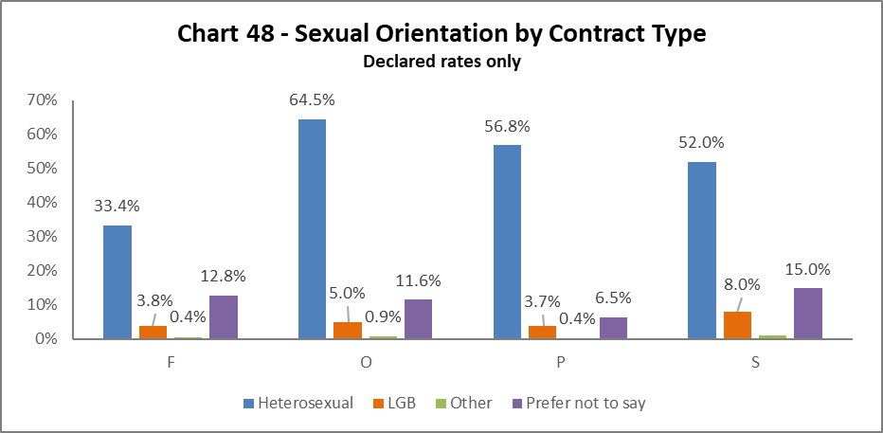

The highest proportion of LGB staff are those on the Fixed term (code S) contracts, however this is a very small percentage of staff. The next highest are on Open ended with funding end dates (O). The lowest proportion are on Open Ended (code P) contracts.

## By Nationality

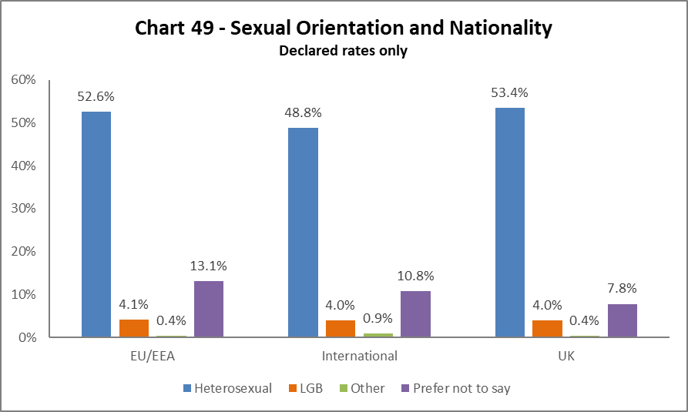

The highest proportion of LGB staff are from the EU/EEA, however this is a 0.5% reduction from 2018-19. International and UK LGB staff have seen minor decreases and increases, respectively, since 2018-19.

## Recruitment – by Applications and Successful Applicants

**Chart 50a - Job Applicants by Sexual Orientation and Job Family.
Clinical - 3.7% LGB, 6.4% PNTS, 9.2% Unknown and 80.7% Heterosexual
MPA - 11.6% LGB, 1.4% Other, 8.4% PNTS, 3.0% Unknown and 75.8% Heterosexual
Operational - 6.7% LGB, 0.4% Other, 10.3% PNTS, 1.2% Unknown and 81.4% Heterosexual
Research & Teaching - 7.4% LGB, 1.9% Other, 10.8% PNTS, 7.4% Unknown and 72.5% Heterosexual
Technical & Specialist - 8.3% LGB, 1.1% Other, 9.2% PNTS, 3.9% Unknown and 77.4% Heterosexual**

**Chart 50b - Job Applicants by Sexual Orientation and Job Family.
Clinical - 3.8% LGB, 3.8% PNTS, 15.4% Unknown and 76.9% Heterosexual
MPA - 10.8% LGB, 1.0% Other, 8.3% PNTS, 12.0% Unknown and 67.9% Heterosexual
Operational - 11.1% LGB, 13.1% PNTS, 5.1% Unknown and 70.7% Heterosexual
Research & Teaching - 7.0% LGB, 1.2% Other, 11.3% PNTS, 25.4% Unknown and 55.1% Heterosexual
Technical & Specialist - 7.4% LGB, 1.1% Other, 10.5% PNTS, 6.3% Unknown and 75.8% Heterosexual**

The proportion of successful LGB applicants closely matches that of the applicant pool across the job families, with Operational staff showing an increase of 4.4%.

# Case Management - General

Chart 51 - Case Management - General Cases by Sex. 
Managing Attendance - Female 81.8%, 18.2% Male
Discipline - 44.4 % Female, 55.6% Male
Grievance - 76.9% Female, 23.1% Male

2019-20 saw a significant decrease in the number of Case Management cases; 61 cases in 2018-19 and 33 in 2019-20. It is notable however, where the numbers were more even in 2018-19, in 2019-20 Females were more likely to go through Managing Attendance (previous Capability) and Grievance compared to Males.

## Case Management – Sickness

The sickness figures relate to staff who have been absent for 20 or more continuous working days between 01 August 2019 – 31 July 2020. This involves 4.1% of staff under report. This is a reduction from 2018-19.

## Age

Chart 52 - Sickness (over 20 days off) by Age Range
One third of all those off sick for over 20 days are aged between 46-55.
25 and Under 1.1%
26-35 - 10.8%
36-45 - 19.7%
46-55 - 33.3%
56-65 - 31.1%
66 and over - 3.9%



Chart 52 shows most staff who were off sick for 20 days or more, were in the 46-55 age group. This a change from 2018-19, where the majority were 56-65 age range.

## Disability

Chart 53 - Sickness (over 20 days off) by Disability
Less than 10% of this off sick for over 20 days have declared a disability.
70.6% - No disability
17.2% - PNTS
3.1% - Unknown

Chart 53 shows the proportion of disabled staff absent for 20 days or more was 9.2%, which represents an increase of 1.5% from 2017-18. This reflects a continuous rise from 2.9% in 2013-14. There is a notably high percentage of staff who chose the ‘Prefer not to say’ category.

## Ethnicity

Chart 54 - Sickness (over 20 days off) by Ethnicity
81.9% - White
5.3% - BAME
1.1% - PNTS
11.7% - Unknown

Chart 54 shows that, of staff who were off sick for more than 20 days, 5.3% are from a BAME background; this is a 0.9% increase from 2018-19 and 1.9% from 2017-18. A relatively high percentage of staff who were off for 20 days or more have not informed us of their ethnicity.

## Sex

Chart 55 - Sickness (over 20 days off) by Sex
65.3% - Female
34.7% -Male

As in previous years, a higher proportion of Female staff have been off sick for 20 days or more than the overall University population as illustrated in Chart 8. This is an increase of 2.4% from 2018-19.

## Sexual Orientation

Chart 55 - Sickness (over 20 days off) by declared sexual orientation
86.8% - Heterosexual
4.4% -LGB
8.8% - PNTS

Chart 56 shows that of those who were off sick for more than 20 days, 4.4% declared as LGB. This is an increase of 1.5% from 2018-19.

# Academic Promotions

|  |  |  |  |  |
| --- | --- | --- | --- | --- |
| **Table 11 - Academic Promotions 2020 - R&T and Clinical Job Families Only** | | | | |
| **Grade Applied For** |  | **Success Rate**  **For Grade** | **Female** | **Male** |
| **GRADE 7** | Applicants |  | 57% | 43% |
| Successful |  | 62% | 38% |
| **Promoted (%)** | **78%** | **86%** | **69%** |
| **GRADE 8** | Applicants |  | 54% | 46% |
| Successful |  | 56% | 44% |
| **Promoted (%)** | **91%** | **95%** | **87%** |
| **GRADE 9** | Applicants |  | 44% | 56% |
| Successful |  | 52% | 57% |
| **Promoted (%)** | **83%** | **82%** | **84%** |
| **READER** | Applicants |  | 24% | 76% |
| Successful |  | 21% | 79% |
| **Promoted (%)** | **82%** | **75%** | **85%** |
| **CLINICAL** | Applicants |  | 56% | 44% |
| Successful |  | 33% | 67% |
| **Promoted (%)** | **67%** | **40%** | **100%** |
| **PROFESSOR** | Applicants |  | 40% | 60% |
| Successful |  | 37% | 63% |
| **Promoted (%)** | **73%** | **67%** | **77%** |
| **SUCCESS RATE FOR ALL APPLICANTS %** | | **83%** | **83%** | **82%** |

Table 11 provides breakdown by Sex of the Academic Promotions 2019-20 process. The overall success rates of Males and Females are almost equal (83% and 82% respectively). However, Females tend to be more successful at Grade 7-8, with Males more successful at Grade 9 and above. The rates for Clinical promotions are particularly low for Females, however the numbers are small.

# Regrading for Professional & Support Staff

|  |  |  |  |  |
| --- | --- | --- | --- | --- |
| **Table 12 - Regrading 2019-20 - Professional and Support Staff by Grade** | | | | |
| **Grade Applied For** |  | **Success Rate** | **Female** | **Male** |
| **GRADE 1-5** | Applicants |  | 79% | 21% |
| Successful |  | 79% | 21% |
| **Promoted (%)** | **100%** | **100%** | **100%** |
| **GRADE 6-10** | Applicants |  | 64% | 36% |
| Successful |  | 57% | 43% |
| **Promoted (%)** | **83%** | **74%** | **100%** |
| **SUCCESS RATE FOR ALL APPLICANTS %** | | **88%** | **82%** | **100%** |

|  |  |  |  |  |
| --- | --- | --- | --- | --- |
| **Table 13 - Regrading 2019-20 - Professional and Support Staff by Job Family** | | | | |
| **Job Family** |  | **Success Rate** | **Female** | **Male** |
| **MPA** | Applicants |  | 74% | 26% |
| Successful |  | 69% | 31% |
| **Promoted (%)** | **83%** | **77%** | **100%** |
| **TECH & SPEC** | Applicants |  | 53% | 47% |
| Successful |  | 53% | 47% |
| **Promoted (%)** | **100%** | **100%** | **100%** |
| **SUCCESS RATE FOR ALL APPLICANTS %** | | **88%** | **82%** | **100%** |

Table 12 above shows in all Grades Males are more likely than Females to be successful in the Regrading process, reflecting previous years. This is within the context of there being a larger proportion of Females in these grades; in Grade 1-5 are 61% Female and in Grades 6-10 are 52% Female. It should be noted the success rate for Females has improved from 2018-19.

Table 13 shows a similar pattern to Table 12, with Males more likely to be successful in all job families compared to Females. It should be noted that the Technical & Specialist job family has had significant success in the Regrading process for both Males and Females. There were no Regrading applications from within the Operational job family in 2019-20.

# Equal Pay

The University has a duty to publish pay gap information by 30th April every two years under Regulation 7 of the Equality Act 2010 (Specific Duties) (Scotland) Regulations 2012. The report for 2021 will be available on that date and will include analysis for sex, ethnicity, and disability.

The University’s Gender Pay Gap will be published along with the Equal Pay reporting document.

**END.**

1. University Strategy 2015-2020
2. As in previous years, MRC staff have been removed from this category and reallocated to the relevant grade based on salary scales.
3. University Strategy 2015-2020